
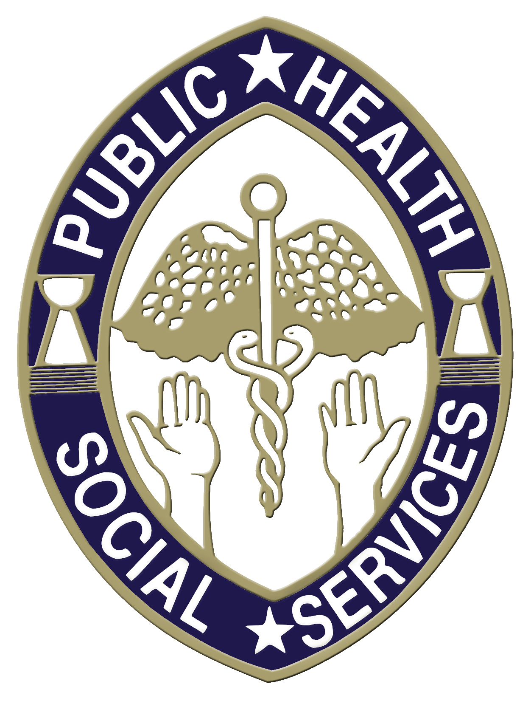

PATIENT PRIORITIZATION CERTIFICATION

_____________________________________
HEAD OF HOUSEHOLD (PARENT OR GUARDIAN)

TOTAL INCOME IN U.S. DOLLARS FROM ALL THOSE WHO SUPPORT THE CHILD OR DECLARE THE CHILD AS A DEPENDENT ON THE PREVIOUS YEAR’S INCOME TAX RETURN (INCLUDE ALL INCOME FROM WAGES, RETIREMENT BENEFITS, PENSIONS, CHILD SUPPORT, ALIMONY, ETC. FOR ALL HOUSEHOLD MEMBERS.

NAME | EMPLOYER/SOURCE OF INCOME | GROSS MONTHLY OR ANNUAL INCOME
1.
2.
3.

TOTAL FAMILY MEMBERS – THE SAME NUMBER DECLARED ON PREVIOUS YEAR’S INCOME TAX RETURN.

NAME | SSN | DOB | CITIZENSHIP | RELATIONSHIP
1.
2.
3.
4.
5.
6.
7
8.

I CERITFY, THAT ALL OF THE ABOVE INFORMATION IS TRUE AND CORRECT.

SIGNATURE: ______________________________________________ DATE: ___________________

FOR OFFICIAL USE ONLY:

[ ] MEDICAID [ ] MEDICALLY INDIGENT PROGRAM(MIP) [ ] SNAP (formerly Food Stamps) [ ] WIC

[ ] FIRST TIME EMERGENCY [ ] DENTAL INSURANCE [ ] MILITARY [ ] MEETS INCOME GUIDELINES

DENTAL CLINIC ELIGIBILITY POLICY

- The purpose of this policy is to implement clinic eligibility criteria based on the State of Hawaii’s poverty income guidelines in order to prioritize patients, such that patients with low incomes, and who do not possess dental insurance, are given high priority. Refer to income guidelines below.

- Patients with incomes above the guidelines will be referred to private providers.

- All patients with private dental insurance will be referred to private providers, even if they meet the income criteria. If unable to access care, these patients will be instructed to seek assistance from their respective insurance company.

- Patients requiring services beyond that provided by the Public Health Dental Clinic will be referred to private providers and they will be responsible for payment for such services.

- Patients who are referred to private providers and who may be eligible for Medicaid or the Medically Indigent Program (MIP) will be instructed to seek such assistance at Public Health’s Division of Public Welfare, Bureau of Economic Security, Central, Northern or Southern Regional Health Centers.

- Patients with dental emergencies/walk-ins will be asked to disclose their income and insurance coverage. Patients with dental emergencies will be referred to private providers if they do not meet the eligibility requirements. Walk-in patients who claim to meet the eligibility requirements will be seen that day regardless of whether they possess proof of income or not, however, proof of income will be required for any follow-up visit.

- Acceptable proof of income includes the two most recent pay check stubs from the parent or legal guardian who supports the child or a copy of the most recent income tax return form filed by parent or legal guardian showing the child as a dependent.

2013 PUBLIC HEALTH DENTAL PROGRAM ELIGIBILITY GUIDELINES

Family Size | Gross Monthly Income | Gross Annual Income
1 | $ 1,103 | $ 13,230
2 | $ 1,488 | $ 17,850
3 | $ 1,873 | $ 22,470
4 | $ 2,258 | $ 27,090
5 | $ 2,643 | $ 31,710
6 | $ 3,028 | $ 36,330
7 | $ 3,413 | $ 40,950
8 | $ 3,798 | $ 45,570

Family units with more than eight (8) members, add $4,620 for each additional member per annum

