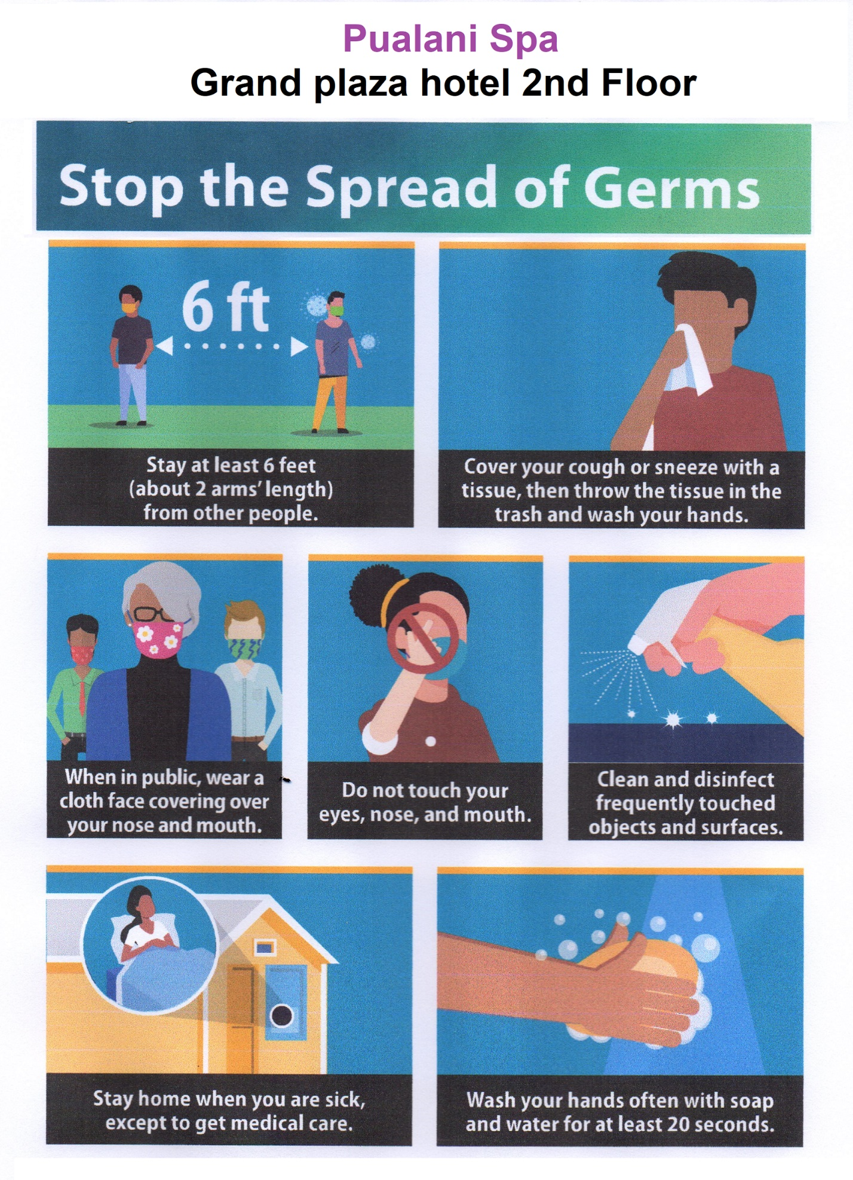

Step for start business
- Test customer body temperatures, when they entrance door.
And must were face mask.
- Washing hand and change store cloth.
- The service worker has limited maximum Two employee same time.
- Not accepted walk-in customers, only appointment.
- After service, changed all used tower and blanket.
- The service employee has to were gloves for body physiotherapy

Please contact: Mary sun 6890559

