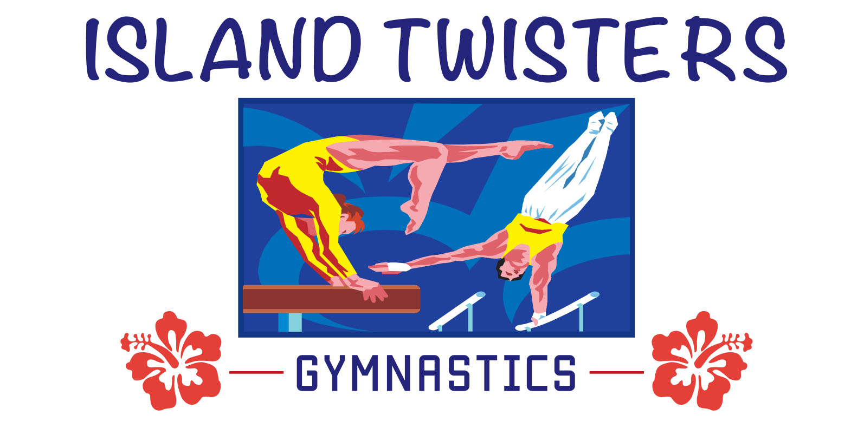
P.O. BOX 3308, HAGATNA, GUAM 96932
(671) 649-3547

PHASE 2 - CONTROL AND PREVENTION MEASURES HANDBOOK FOR REOPENING DURING COVID-19

ISLAND TWISTERS PHASE 2: OPEN WITH SMALL GROUP CLASSES FOR AUGUST 2020.

ISLAND TWISTERS WILL OPEN IN PHASE 2 WITH ONLY SMALL GROUP GYMNASTICS CLASSES.
Island Twisters will offer small group classes that consist of no more than 6 students. Student classes will have separate time and/or day slots and will be divided into beginning, intermediate & advanced gymnasts that range from ages 7 – 18 yrs. old. Classes will involve having only 5 - 6 students in a class inside the 5000 square foot gym with 2 coaches coaching them. Each coach will have no more then 3 beginner students at a time. Intermediate and advance classes will be in different time slots and are divided into separate sections of the gym with 5 students in a class with 1 or 2 coaches. Students must stick with the same day and time for the 4 weeks. Students that want to change their schedule at the end of the 4 weeks will be put on a “wait list” until a spot is available for the different day that they want to change to.
Beginner classes will be 55 minutes long instead of 1 hour. 5 minutes is allowed between each class for cleaning, wipe-down and transition of one group leaving and the next group coming in. Gym will be cleaned and sanitized during class, after rotation of events, and will also be cleaned at the end of each day.

Students, parents and employees will have their temperature checked upon entering the facility. (Needs to be 99.5 or lower to come inside.) If temperature is not at 99.5 or lower, they will not be let into the facility. Students, parents and employees will also need to wash or sanitize their hands.
We have a total of 4 washing sinks that are ready to use. Below is the placement of the sinks inside and outside of the gym:
1 portable sink by the entry front door.
1 portable sink in the gym.
2 permanent sinks that are in the gym bathrooms. (We have 2 bathrooms.)

Coaches will wear masks. Students will wear masks coming into the gym but then will take them off when they start working out. Students need a gym bag to bring inside the gym to put their mask inside of when they start working out. Students will workout on gymnastics events that are spaced out more than 6 feet apart. (The gym is 5000 square feet and with only 5-6 students in it this will be easy to space them out.)
There will be no sharing of the chalk bowl for bars. Beginner students will not use chalk and the bars will be sanitized after rotations and student will have to wash their hands after using the bars. Island Twisters have provided intermediate and advanced gymnasts with their own ‘chalk’ plastic container with their name on it. Apparatus will be wiped-down after each rotation. Students will be asked to wash or sanitize their hands between the rotations and at the end of class. Students that have any flu like symptoms such as fever, cough, sneeze, body aches etc. will not be permitted to come to class. A make-up class by appointment may be scheduled when they feel 100% well. If the student passes the temperature check but we notice that they have flu like symptoms, we will send them home.

We prefer parents to drop off their child and leave. If the parent does come inside, we will take their temperature and ask them to wash or sanitize their hands. Parents are asked to not hang out too long in the reception area or viewing room. Only 4 people are allowed in the reception area (600 square feet) at one time and only 2 people are allowed in the viewing room (96 square feet) at a time. No children will be allowed in the reception area or viewing room to “hang out” if they are not signed up for the class.
There is a plexiglass divider on the reception cashier desk. We have signs posted on the front door, reception desk barrier, and throughout the gym and facility that reminds customers in keeping the
6 feet social distancing protocol, washing their hands and wearing their facemask.

Below is a checklist for the general cleaning procedures and a checklist for each apparatus event that has more specific detailed cleaning instructions.

Cleaning Procedures:
Wipe-down and disinfect commonly touched areas.
(Door handles, light switches, table surfaces, matting, etc.)
Clean the bathrooms between classes.
Make sure hand-sanitizer is full and dispersed throughout facility.
Clean the apparatus and fill in cleaning log sheets that is by each apparatus.
Deep cleaning that involves washing and air-drying; along with steam cleaning that will be done after gym hours at night.

Vault Cleaning:
Tidy up the area to eliminate any hazards.
We will put a panel mat over the top of the vault table for students to use to vault over the vault.
(The vinyl mat covering will be easier to clean then the leather vault top)
Wipe down the panel mat that is on top of the vault table with a cleaning supply and disinfectant.
Vacuum the vault area.
Vacuum the vault runway and vault board tops.
Wash the vault column and vault base
Wash vault mats around the vault with cleaning supplies.
Allow area to dry before use.
Fill in cleaning log sheet.

Bars:
Tidy up area to eliminate any hazards.
Wipe rails with damp cloth with TRUCE chalk remover and disinfectant or similar product.
Sweep or vacuum chalk from mat and floor.
Wipe down apparatus with disinfectant.
Apply cleaning to all matting using a sprayer or microfiber mop or cloth.
Allow area to dry before use.
Fill in cleaning log.

Beam:
Tidy up the area to eliminate any hazards.
We have a removable beam cover that fits tightly over the beam that will be cleaned.
Use soft scrub brush to remove dirt and chalk from the beam top.
Vacuum the area around the beam.
Wash the beam cover with a damp micro fiber cloth coated in a disinfectant solution.
Using a clean cloth apply cleaning solution to all the steel of the beam legs.
Clean the matting under the beam with cleaning and disinfectant supplies.
Allow area to dry before use.
Fill in cleaning log.

Floor:
Tidy up the area to eliminate any hazards.
Vacuum carpeted surface.
Steam clean carpet using a light detergent after gym hours weekly.
Wash all mats with a light detergent.
Allow area to dry before use.
Fill in cleaning log.

Tumble Trampoline:
Vacuum or sweep trampoline bed.
Wipe down and clean the top of trampoline with cloth and disinfectant solution.
Wipe down padding with cleaning supplies.
Sweep or Vacuum crash mat and clean with cleaning solution and cloth.
Allow area to dry before use.
Fill in cleaning log.

No rope climbing will be allowed.

Provide a Safe Environment for Employees

• Employees will have their temperature taken upon entry. (Needs to be 99.5 or lower to enter.)
Employees will be asked if they or their family at home have any Covid-19 flu like symptoms,
such as fever, cough, sneeze, body aches, etc. and if they answer yes than the employee will not
be permitted to come inside to work.
• Employees need to wash their hands upon entry.
• Employees must wear facemasks at all times.
• Coaches will conduct classes with mostly verbal instruction only. If spotting is needed, gloves will
be used and disposed of after the use of each gymnast and/or hands will be sanitized after spotting
each gymnast.
• We will train and educate staff on updates and changes to Island Twisters policies, especially
social distancing and other Covid-19 guidelines.
• We have updated and distribute Island Twisters policies in a written form to students, parents, and
staff.
• We have updated and distribute participant waivers to parents and staff.

Parent/Guardian Responsibilities

• Parent will be informed of the gym’s new safety protocols and their family’s role in maintaining
safety guidelines for themselves and others, including:
- ensuring their child and immediate household members are free from illness before coming to the gym (when in doubt, stay home!)
- providing their child with personal items for the gym (gym bag, water bottle, grips, tape, hair ties, etc.)
- talking to their children about keeping a 6-foot distance, washing hands, cleaning equipment and following gym rules.
- Making sure child takes shower after class and clothes used for class need to be washed.
• Parents will be notified to drop off student and come back in 1 hour to pick up student is
preferred instead of waiting in the lobby. Parents will be asked to refrain from gathering in
groups while in parent waiting area and the outside entryway. We will remind them of the
social distancing 6-foot guidelines.
• Parents will be reminded to use hand sanitizer and to use masks or face coverings at all times
while in the facility.

Guidelines will be reviewed on a weekly basis to see if adjustments are needed to ensure safety.
Any further questions that you may have, you may contact Derrick or Melinda Heath at 649-3547, please leave a message on phone machine if receptionist is not available to answer.
Thank you,
Derrick (Ric) and Melinda Heath
Owner of Island Twisters Gymnastics
649-3547

