ZENG’S STUDIO
PLEASE SIGN IN!
WE WILL BE ALLOWING ONE (1) CUSTOMER AT A TIME IN THE SALON. KINDLY WAIT IN YOUR VEHICLE. STRICTLY NO WAITING INSIDE THE SALON.
PLEASE NOTE THAT WE ARE CURRENTLY ONLY “BY APPOINTMENT BASIS ONLY”.
Salon will be doing temperature check and thoroughly cleaned and disinfected before/after every client, so please give us a few minutes for sanitizing before your scheduled appointment.
ZENG’S STUDIO CLIENTS will follow 3W’s: Social Distancing, Face Mask and Wash Hands!
With the safety of our clients and staff in mind we ask that if you have symptoms such as coughing, sneezing, fever or if you have traveled recently and have been instructed to self quarantine we ask that you reschedule your appointment to a later date. We are taking this situation very seriously and ask that all clients and staff keep their own health as well as others in mind.
WE APOLOGIZE SINCERELY FOR THE INCONVENIENCE BUT DURING THIS DIFFICULT TIME, SAFETY OF ALL IS OUR NUMBER ONE PRIORITY.

PLEASE CONTACT ZENG AT: 687-5388
**If employees of Zeng’s Studio feel any symptoms, salon will not operate**
Thank you for your cooperation
ZENG’S STUDIO
MASK IS REQUIRED OR NO ENTRY

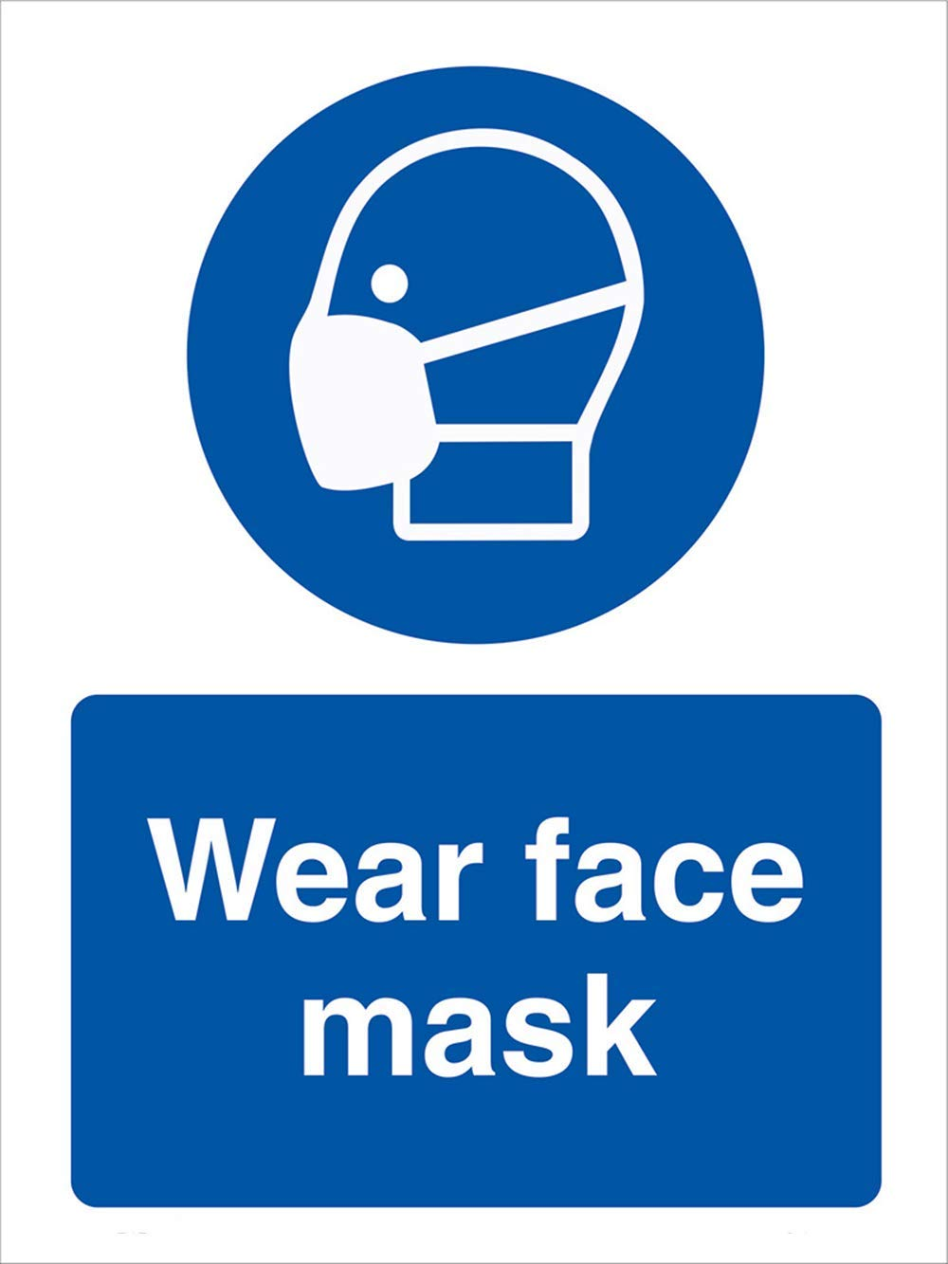

PLEASE MAINTAIN 6FT BETWEEN INDIVIDUALS
