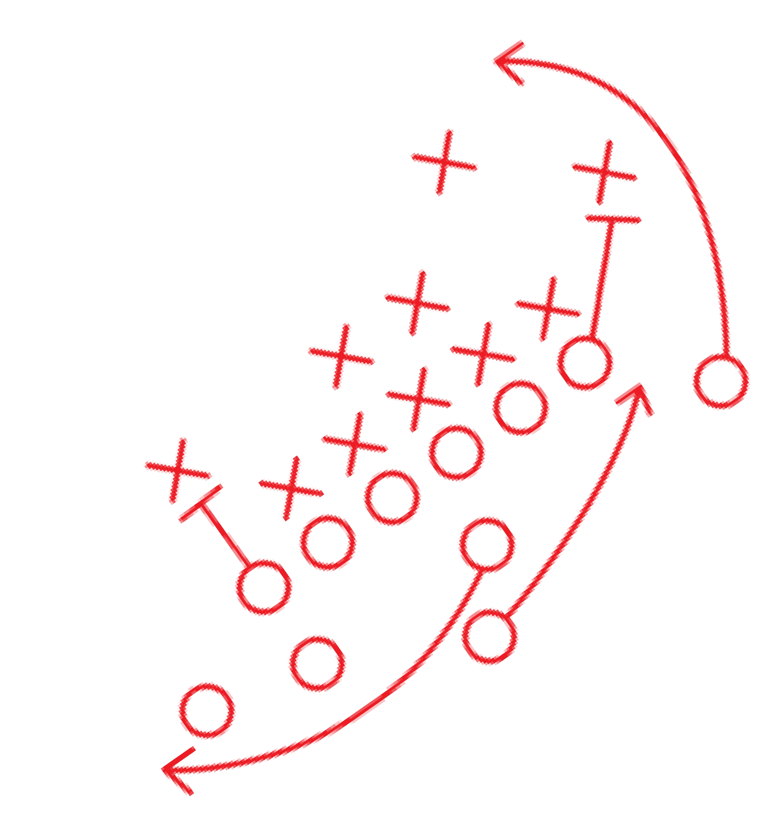
Private and Confidential Information - TGI FridaysTM 2020 1

OPERATIONAL PROCEDURES

UNDER COVID-19 2020

TABLE OF CONTENTS

OUR OPERATIONAL ABSOLUTES | 4 | 5 BOH CONTROLS | 40
OUR GUIDING PRINCIPLES | 6 | HAMBURGER STANDING FOR TO GO | 42
REOPENING FRIDAYS | 7 | TO GO PACKING STANDARDS | 43
WHAT IS CORONAVIRUS? | 8 | DELIVERY PARTNERS | 44
SANITARY, SAFE, & SPOTLESSLY CLEAN | 9 | LINE CHECKS | 45
OVERVIEW OF POLICIES/PROCEDURES | 10 | THE PERFECT FRIDAYS EXPERIENCE | 47
TEAM MEMBER WELLNESS CHECKS | 11 | REDUCED OCCUPANCY AND WAITLIST GUIDANCE | 49
REPORTING ILLNESS | 13 | OTHER MANAGER RESPONSIBILITIES | 50
SELF ISOLATION | 15 | DELIVERING THE PERFECT CURBSIDE FRIDAYS EXPERIENCE | 51
MAINTAINING A HEALTHY ENVIRONMENT | 16 | CONTACTLESS CURBSIDE PROCEDURES | 52
PRE-OPENING CLEANING GUIDELINES | 22 | CURBSIDE MERCHANDISING | 55
CLEANING SCHEDULES | 24 | CURBSIDE MARKETING MATERIALS | 56
EVERY HOUR HIGH TOUCH POINT CLEANING CHECKLIST | 25 | TO GO PACKAGING STANDARDS | 58
CLEANING SCHEDULES | 26 | DETERMINED LEADERSHIP | 59
MONTHLY CLEANING CALENDAR | 29
SERV SAFE CERTIFICATION | 30
THE RIGHT PEOPLE | 31
INVITING BACK THE RIGHT PEOPLE | 32
ORIENTATION | 34
TRAINING | 35
PERFECT FOOD, PERFECT BEVERAGE | 39

2

WELCOME

To the Determined Leader holding this Playbook,

There has never been a time when Determined Leaders were needed more than they are right now. The world is in crisis and everyone is adjusting to new normals. Luckily at Fridays, we have our Operational Absolutes to ground us, our Guiding Principles for making decisions, and this playbook to direct our actions.

As we write this note, states are setting timelines and guidelines for restaurants to re-open their dining rooms for service. And our Guests are determining where to put their trust as they venture out of the homes that they've sheltered in for weeks. For many restaurants, you've already started the journey to earning that trust with your meticulous Sanitary, Safe, and Spotlessly Clean standards and your Perfect Fridays Curbside Experiences.

And you've already shown that Fridays cares for its communities by caring for our furloughed Team Members and supporting our doctors, nurses, fire fighters, police officers and grocery store workers.

As restrictions are lifted, we are poised to lead our industry from the front, being worthy of our Guests' trust, simply by executing our Operational Absolutes.

- Our Right People will be well trained, caring, and respectful to support our Guests' new needs.
- We will continue to make and serve the Perfect Food and Beverage that Guests have been missing.
- We will deliver the Perfect Fridays Experience for today's Guest, respecting social distancing guidelines and taking necessary safety measures while still making Guests feel welcome and giving them a sense of normalcy.
- As always, we will continue to meet or exceed industry standards for operating a Sanitary, Safe, and Spotlessly Clean restaurant.
- You, our Determined Leader, will successfully guide your team through these changes, creating a stronger culture coming out of this time than you had before the pandemic.
- And finally, we will Grow our Sales and PACE through creative thinking and lifting our communities.

Thank you for your commitment and dedication to Fridays and to your teams. We look forward to hearing how your leadership impacted your people, your communities and your results.

OUR OPERATIONAL ABSOLUTES

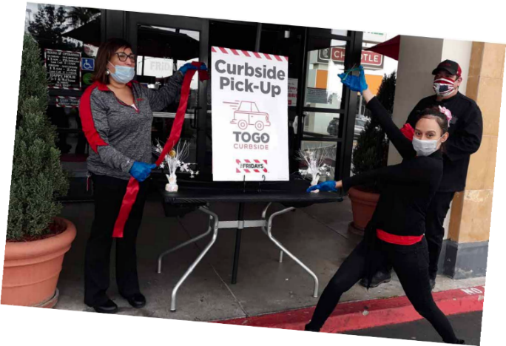
Our Operational Absolutes are the key elements to effectively executing the business on a daily basis. Every shift is delivered with a purpose and focus dedicated to the success of the organization. Use these foundational principles as the blueprint for running a winning restaurant.
THE RIGHT PEOPLE
We jealously guard who gets to play on our teams at Fridays because we know that The Right People bring our restaurants to life! And they do it through bringing our Operational Absolutes to life.
The Right People are charming, authentic, impeccable, and amazing party hosts. They are People of All Stripes who go out of their way to give our Guests the Perfect Fridays Experience.

THE PERFECT FRIDAYS EXPERIENCE
Every engagement with Fridays is an opportunity for us to deliver a social and memorable experience. We care deeply about each and every Guest who chooses to spend time and hard-earned money with us. The Perfect Fridays Experience means service that exceeds our Guests’ expectations and working with a sense of urgency and purpose whether the Guest will dine in or eat at home/work.

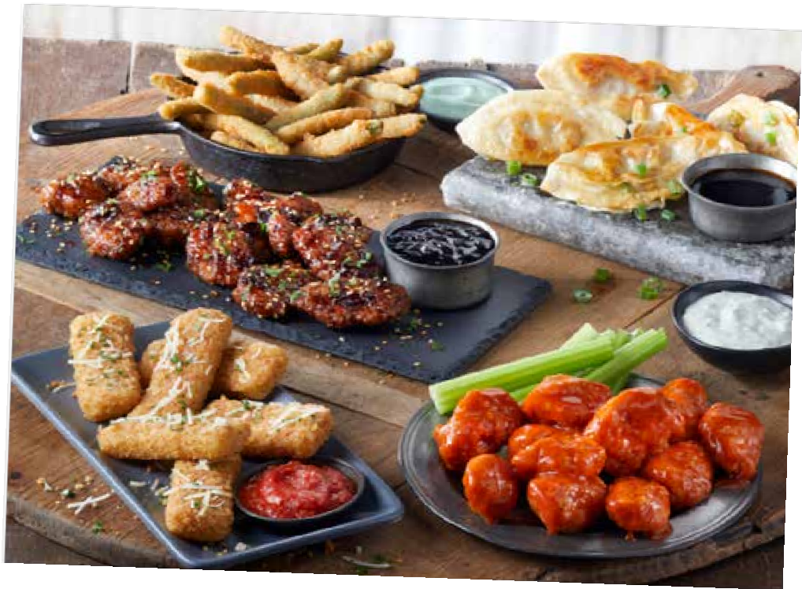
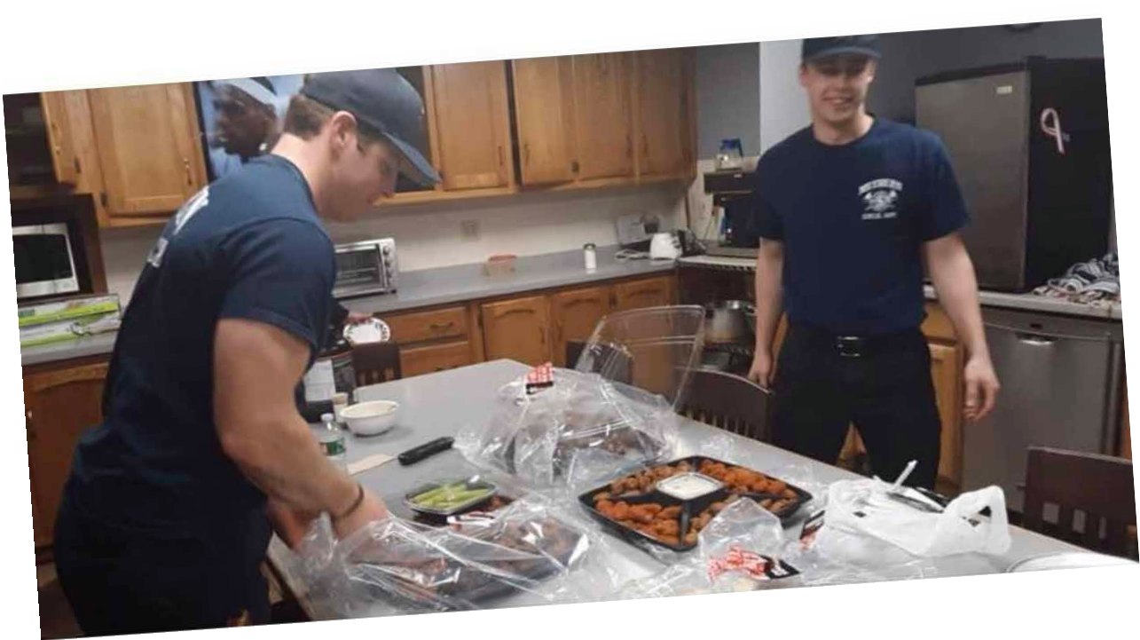
PERFECT FOOD, PERFECT BEVERAGE
Using practices that help Team Members feel confident, capable and in control of the outcome of their work, Team Members feel empowered to do their work effectively and without excessive oversight or micromanagement.
Leading and living by example isn’t as hard as it might sound. It’s really the easiest path. If your team knows that you’ll do whatever you expect from them, they’ll likely work hard to help you achieve your goals and deliver Perfect Food, Perfect
Beverage.

4

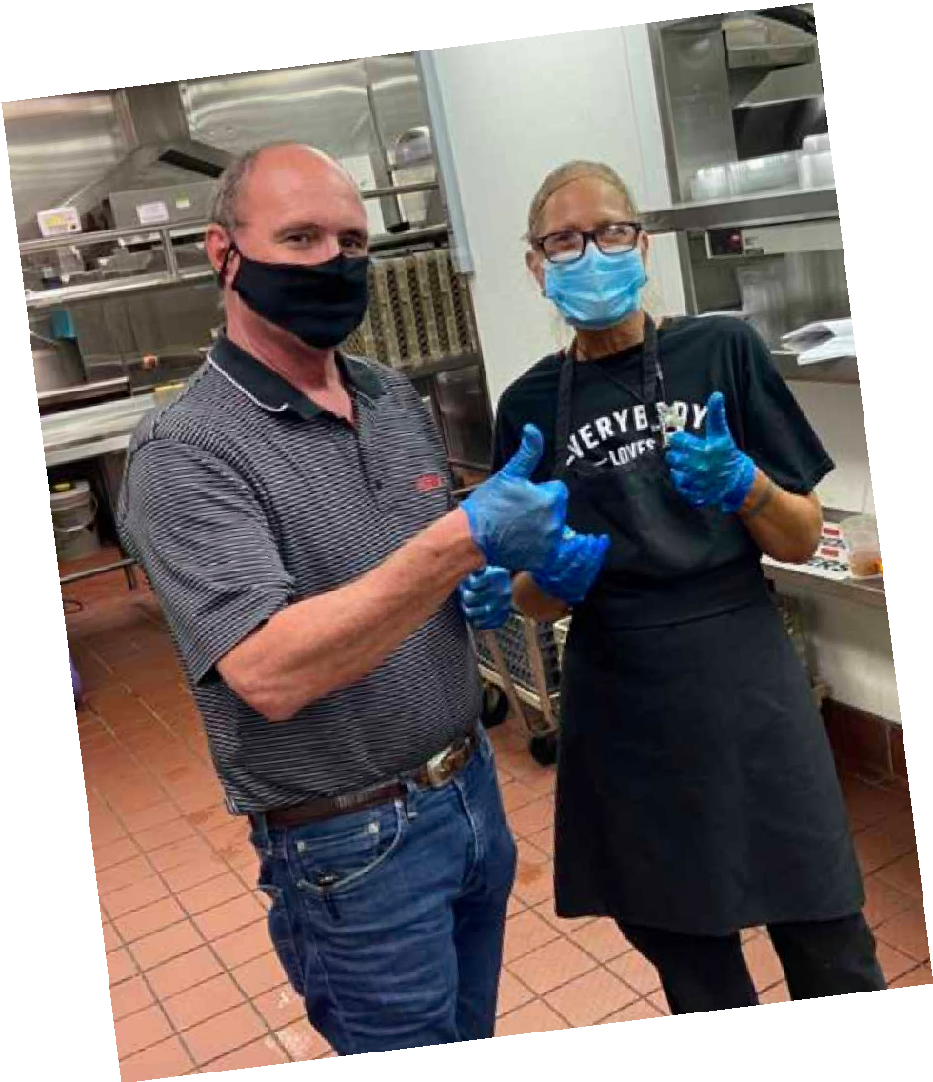
SANITARY, SAFE, & SPOTLESSLY CLEAN

Our restaurants are an illustration of our standards. Every Team Member must have the tools and knowledge to precisely execute the standard. Proper training and well-designed safety systems protect our Team Members and Guests. From the edge of the parking lot to the back door, we are responsible for Sanitary, Safe, and Spotlessly Clean restaurants.

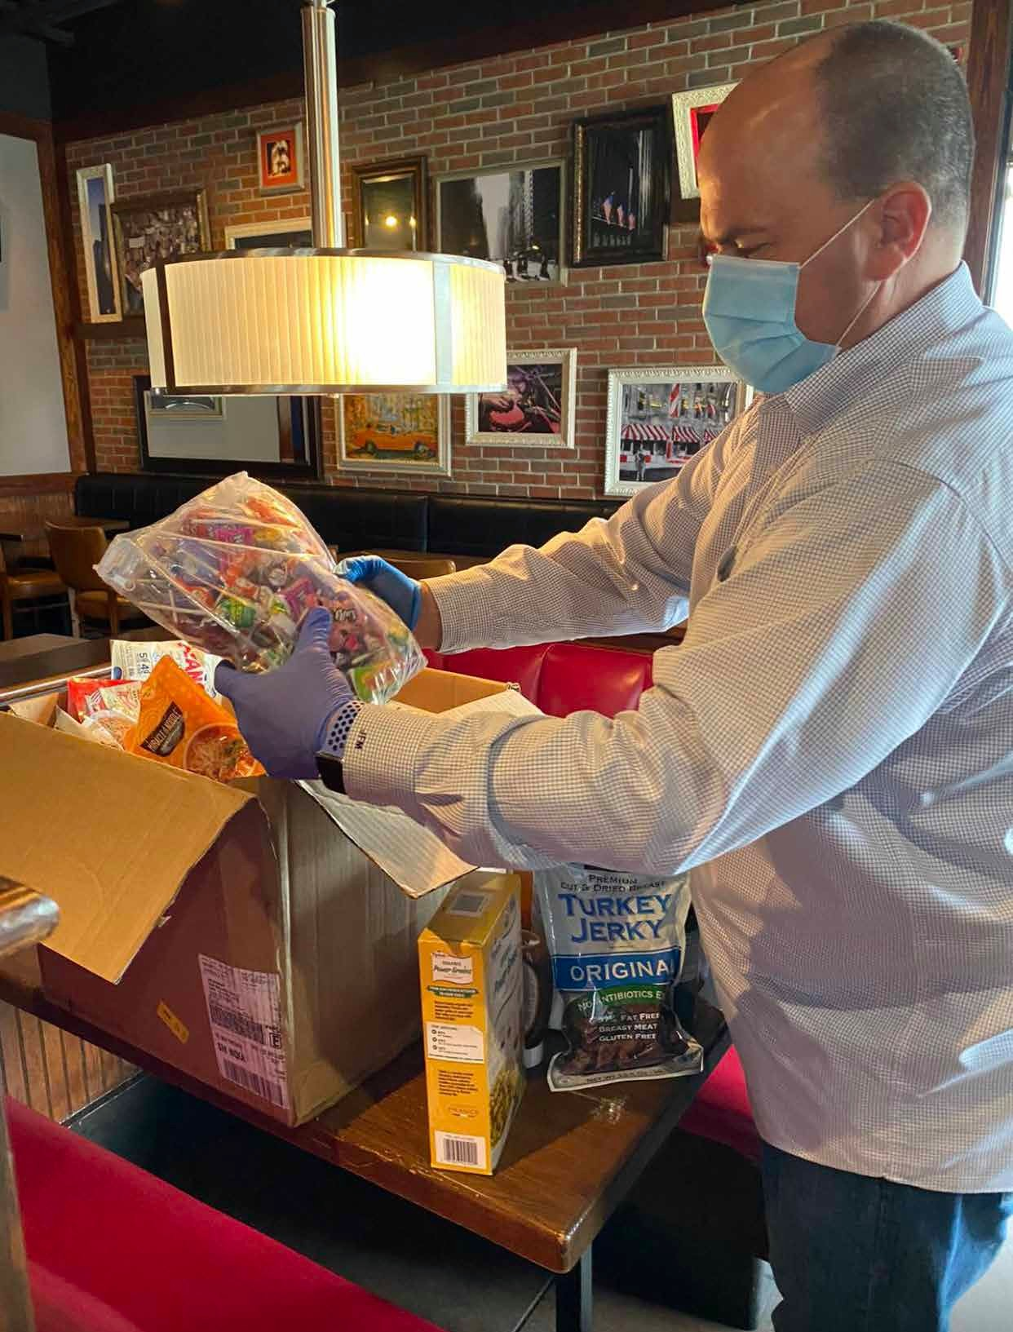
DETERMINED LEADERSHIP

Great leadership takes strength of character and a firm commitment to do the right thing, at the right time, for the right reason. This means doing what you say you will do. Determined, dynamic role models recruit, train, develop future leaders, and effective teams to deliver on the highest standard of service. Determined Leadership means approaching all situations with a sense of urgency and purpose, setting direction for the team, and delivering positive results. Exceptional leaders always do the right thing and celebrate success by catching people doing things right.

Our Guiding Principles

We care deeply about the health and well-being of our Team Members, Franchisees and Guests. This is our No.1 priority.

We will react swiftly to the changing needs of our Team Members, Franchisees and Guests.

We recognize our role within our communities and will be a positive contributor whenever possible.

We will base our decisions on expert guidance from the Center for Disease Control and World Health Organization. We will follow all legislation and take direction from Government leaders, individual state departments, and local health agencies.

We will cease all non-essential spending and unnecessary expenses to responsibly preserve cash.

We will commit our resources to mission critical priorities while assisting our restaurant leadership/ownership through the situation.

We will communicate promptly and as fully as possible to support

REOPENING FRIDAYS
Restaurant Implementation Guide
TGI Fridays has implemented multiple procedures and guidelines to address Covid 19 outbreak in 2020. Novella Coronavirus 2019 is a New Respiratory Virus which first surfaced in December 2019 in Wuhan China. As a result of the virus, the disease it causes is Covid-19 which currently there is no vaccine.

In addition to our current Standard Operating Procedures, Sanitary, Safe and Spotlessly Clean program, Fridays is following the CDC and World Health Organization Guidelines. TGI Fridays will also be in compliance with Federal, State, County and Local executive orders.

Prior to this pandemic, TGI Fridays had best in class the Sanitary, Safe and Spotless Clean Programs. Due to the pandemic, Fridays has implemented additional measures to prevent the spread of the Coronavirus.

THIS INCLUDES:
  - Monitoring Local State, County and city for guidelines in case of such outbreaks
  - Increased Employee Health Monitoring which includes Temperature checks
  - Social Distancing by maintaining a 6-foot distance from each other
  - Increased Personal Protective Equipment (PPE) – Wearing a mask during work, Wearing Gloves
  - Increased Disinfecting of high touch surfaces
  - Continuous Team Member Education on:
The current situation as it relates to the Restaurant and the Team Members The procedures to help prevent the spread the coronavirus
    - Increased Handwashing
    - Social distancing – 6 feet
    - Wearing a mask prevents saliva from spraying out of the mouth to others
    - Not touching the eyes, nose or mouth
    - Proper use of gloves
    - Safe Guest Procedures
    - Sanitizing the restaurant if a person has Covid-19 or was in direct contact with a person with Covid-19.
    - Self-Isolation for 16 days for the person that has Covid-19
    - Self-Isolation for the person that was in direct contact with someone who has Covid-19
    - Getting tested for Covid 19

WHAT IS CORONAVIRUS?
The Coronavirus is a is a respiratory disease virus. There is no link between the Coronavirus and foodborne illness. All Foodborne illnesses are gastrointestinal tract infections. The main concern is that Coronavirus is easily transferred from person to person by inhaling Coronavirus particles. The Coronavirus particles go airborne, (a person sneezes and someone inhales at that moment) or if a person coughs or sneezes and the droplets land on a hard surface. Every person who touches the area where the droplet landed and then puts their hand to mouth, nose or eyes could become infected. One droplet the size of a needle pin head can get 1000 people sick.

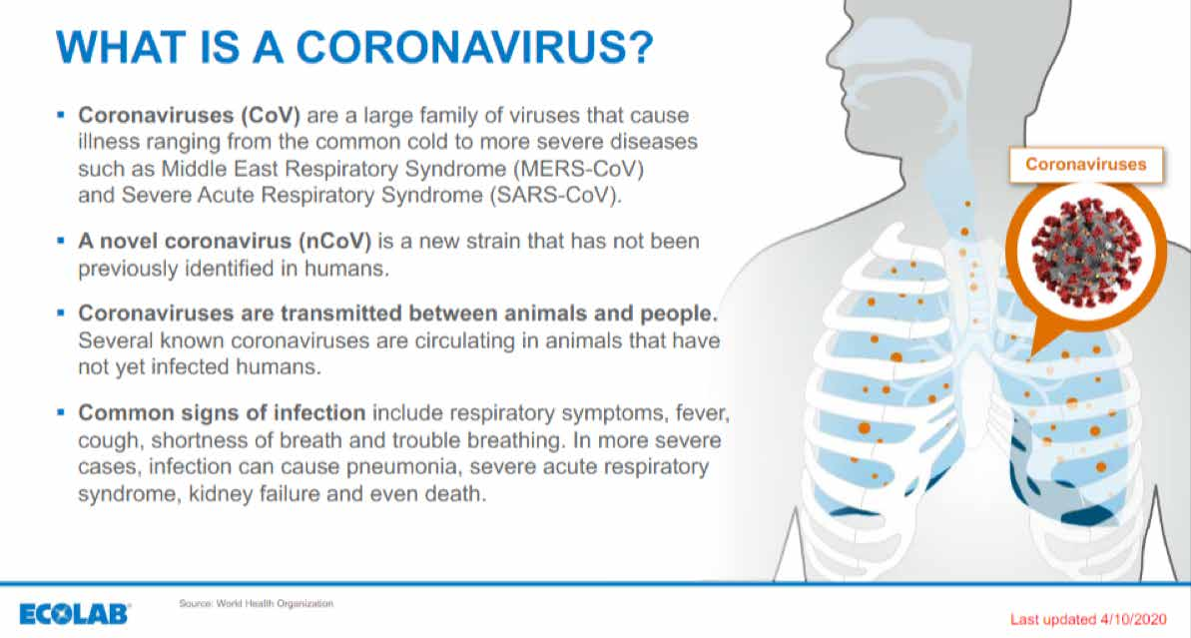

HOW TO USE THIS PLAYBOOK
This book will provide you with a summary of practices that can be used to help mitigate exposure to the COVID-19 virus. It also includes a full operational playbook for re-opening our dining rooms and welcoming back our Guests. Our strategies are deliberate, and we are committed to delivering a Perfect Fridays Experience while providing a safe environment for our Team Members and Guests.

SANITARY, SAFE, & SPOTLESSLY CLEAN

Our Guests come to Fridays for Perfect Food, Perfect Beverages. No matter what your position in the restaurant, you are responsible for delivering a Perfect Fridays Experience to every Guest in a Sanitary, Safe and Spotlessly Clean restaurant, all with industry leading food safety excellence. If you express the utmost care in preparation of our Guests' meals with attention to detail in safe food handling, recipes and plate presentation, this goal will be met.

SANITARY
} Prevent the spread of illness by maintaining healthy work environments
} Understanding proper temperature control
} Practice good hygiene and reporting illness
} Reduce pest attraction

SAFE

} Create a safe environment for our Team Members and Guests
} Social distancing
} Understand the top allergens
} Reduce accidents and risk of slips, trips, and falls

SPOTLESSLY CLEAN
} Attention to detail and commitment to the highest Brand Standards
} Diligently adhere to the FOH/BOH Cleaning and Sanitizing Standards

Tools and Resources
These manuals are your tools and they all work together in harmony and can be found on Sharefile.
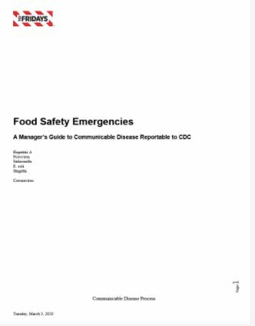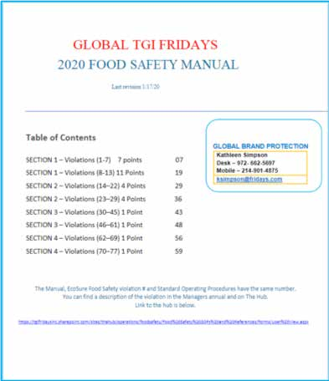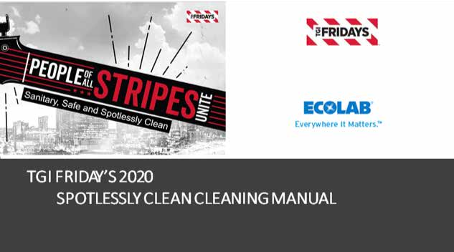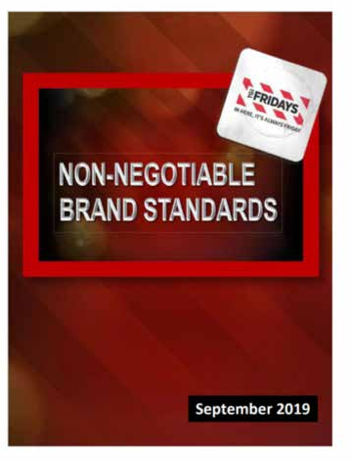

Communicable Disease Policy
A Manager’s Guide to Communicable Disease Reportable to CDC.
Food Safety Manual A comprehensive book which list all the food safety criteria that is
covered by an EcoSure specialist during an unannounced
restaurant audit. It is also everything a health inspector is looking for.

Spotlessly Clean Cleaning Manual
The BOH and FOH Cleaning Guidelines will walk you through step by step restaurant cleaning sanitizing the equipment with the proper chemicals and the frequencies of cleaning.
Non-Negotiable Brand Standards A comprehensive guideline which list
all the TGI Fridays
Brand Standards.

OVERVIEW OF POLICIES/PROCEDURES

As your restaurant re-opens to the public, there are several updated and new procedures that our teams must be trained on and able to execute with Steel Pole consistency every shift and in every Guest interaction. Below is an overview of all the information you will find in this chapter.

Team Member Wellness Checks - All Team Members need to know the symptoms of Covid-19 and are prohibited from coming to work if they suspect they may be ill. Managers will be required to screen all Team Members before their shifts.

Physical/Social Distancing - At Fridays, we love being social, but we will comply with all Social Distancing guidelines provided by the CDC including creating an environment in our restaurants that allow Guests and Team Members to remain 6 ft apart.

Mask & Glove Usage - Because remaining 6 ft. apart is not always possible in restaurants. Fridays is requiring all Team Members and Managers to wear masks. We are also requiring gloves to be worn whenever they are handing something to a Guest: food, beverages, To Go bags, the check, credit cards etc.

Handwashing and Hand Sanitizing - We will wash or sanitize our hands in compliance with our internal policies and CDC guidelines and we will encourage our Guests to do the same.

Enhanced Service Steps - From offering an option to serve Guests from a 6 ft. distance to promoting contactless payment options we will help Guests feel safe during the Perfect Fridays Experience. See the Perfect Fridays Experience Chapter for more details on these steps.

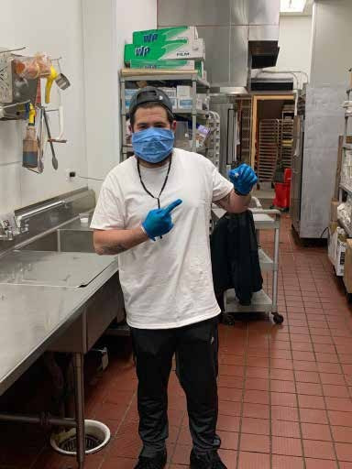
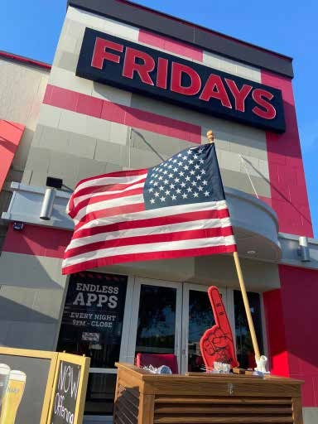
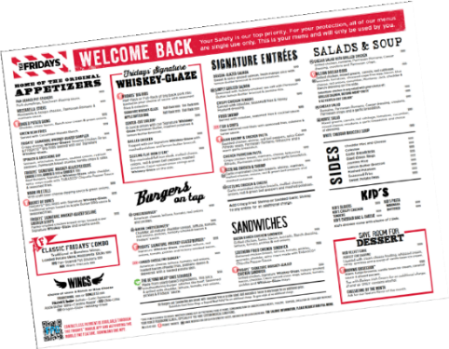
New Dining Room Set Up - Easily accessible hand sanitizer, a socially distanced seating chart and nothing pre-set on our tables will signal cleanliness to our Guests. See the Perfect Fridays Experience Chapter for more details.

New POP - We will begin using single use menus for food and beverages, post signage communicating our Sanitary, Safe and Spotlessly Clean practices and have visible floor decals to help Guests maintain social distance standards in our higher traffic areas. See the Perfect Fridays Experience Chapter for more details.

More Frequent Cleanings - We were already practicing
cleaning procedures effective against Coronavirus; we are
now going to enhance them by cleaning high contact areas
of our restaurant every hour and disinfecting tables and
chairs in between each party.

Best Practice Sharing and Communication - As our
restaurants start to re-open and we learn from each other,
we will share best practices and lessons learning with each
other to enhance our re-opening policies and procedures.

TEAM MEMBER WELLNESS CHECKS

Monitoring Symptoms
POLICY: TGI Fridays Managers will perform wellness checks for every Team Member prior to the beginning of each shift.
- Team Members who are sick or who appear to have COVID-19 symptoms should be separated from other Team Members/Guests and immediately and sent home
- Immediately clean and disinfect areas the sick Team Member visited.
- Train Managers/leadership to spot symptoms of COVID-19 and to be clear on relevant protocols

PROCEDURE: Each Team Member should report any illness or if they are not feeling well to a Manager by phone prior to the start of their shift. Instruct them not to come in if they are sick. Symptoms include (fever, cough, muscle aches and pains, sudden changes in smell or taste, sore throat, and/or shortness of breath)

Take Team Members temperatures prior to the start of a shift, according the Team Member Temperature Procedure. Do not write down or record daily temperatures of Team Members.

If the Team Member's temperature is above 100.0°F:
- Record on the Wellness Information Form using only the YES or NO answers
- Ask them: When did the symptoms begin? On average it takes 5–6 days from when someone is infected with the virus for symptoms to show, however it can take up to 14-days before they display symptoms.
- Report the information to PriorityNotifications@fridays.com and your HR representative.
› Franchisee designated contacts will vary. Please verify with your Regional Manager/RVP.
- Send the Team Member home and ask them to call their healthcare provider.
- Conduct a deep cleaning of the restaurant and immediately sanitize any areas they have come in contact with.

Covid-19 Team Member Action:
- If the Team Member has stated they are confirmed to have COVID-19, they must self-isolate for 16 days and follow guidance from their doctor and the Centers for Disease Control and Prevention. The Team Member must fill out the Self isolation form and send the completed form to ksimpson@fridays.com.
- If it is unknown if the person has Covid-19, the Team Member cannot return to work until they are 72 hours symptom free. With COVID-19, additional precautions are needed to ensure the safety of the rest of the team.
- If the person working is confirmed with Covid-19 the crisis team must be notified by the GM or DO. Restaurants should work with the crisis team to discuss next steps.
- If a person is living with a person that is confirmed with Covid 19 the Team Member must self-isolate for 16 days.

Wellness Information Form
Team Member Name:
Was Team Member in contact with Diagnosed w/Covid-19 Person? |  | Yes or No
Restaurant Name & Number: |  | Date Symptoms Began:
Did Team Member visit a Doctor? | Yes or No | Date Last Worked:
Was Team Member Diagnosed? | Yes or No | Date Isolation Starts:
Experienced Common Symptoms? | Yes or No | Experienced other Symptoms? | Yes or No
Fever 100.4°F & above |  | Aches and Pains
Tiredness |  | Nasal Congestion
Dry Cough |  | Runny Nose
 |  | Sore Throat
 |  | Diarrhea
Notes:

THERMOMETER PROCEDURE
ེ Prior to taking a Team Member's temperature wash hands, change into new gloves, and always wear a protective mask.
ེ The Team Member is also required to wear a face mask.
ེ The Team Member must acclimate to the temperature within the building for 10 minutes prior. The outside temperature can impact the results.
ེ Take the thermometer at the center of the forehead around 1-2 inches away from the forehead.
ེ Read the results on the digital display.
ེ If the temperature is 100.0° F (or 38 C) or higher, retake the temperature. If the reading is the same the Team Member should be immediately excluded from work.
ེ When finished, wash your hands and gently sanitize the thermometer per instructions or with a sanitizing wipe.
ེ Please store the thermometer in a secure place in the office between uses.

Thermometer Example
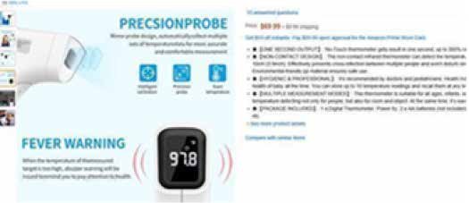

REPORTING ILLNESS

An important part of running a restaurant is to maintain a healthy environment for both our Guests and each other. You play an important role in this area. Keep in mind how important this is for our restaurant. A single health problem could cost us our business, our reputation, and our jobs. Awareness of these problems will prevent serious issues from arising.

Observe Team Members for symptoms of illnesses. Team Members, including Managers, who have cold/flu-like symptoms (such as jaundice, sore throat with fever, vomiting, excessive coughing or sneezing, diarrhea, etc.) or any communicable or infectious disease must not be allowed to work. Symptomatic Team Members must not be allowed to work since he/she may pass pathogens to the Guest.
} The Manager will exclude a Team Member from work if he/she has sore throat with fever, vomiting, or has diarrhea, jaundice, Hepatitis A, Salmonella, symptomatic Shigella, symptomatic E coli, and symptomatic Norovirus/Coronavirus
} The Manager will restrict a Team Member from working with food if he/she has an infected wound (if covered with a bandage and glove), asymptomatic Shigella, asymptomatic E. coli, or asymptomatic Norovirus.

STEP | ACTION
1. Employee is Ill | Employee is removed from work and visits a doctor.
2. Preliminary Diagnosis | Testing by Doctor
Scenario #1:  Diagnosed with Non- Communicable Disease | Employee is diagnosed with non-communicable disease, recovers, and returns to work.
Scenario #2:  Waiting for Diagnosis | - Employee remains off work schedule.  - Restaurant Management calls the Crisis Team 877-742-1213  - Restaurant Management calls DO/ Operator/VPO  - Management emphasizes personal hygiene practices at restaurant.  } Wash your hands frequently and thoroughly with soap and water for at least 20 seconds. possible, use an alcohol- based hand sanitizer that contains at least 60% alcohol. SOP 7  } Avoid touching your eyes, nose, and mouth. SOP 7  } Stay Home, if you are sick or have persistent coughing and sneezing. SOP 6  } Clean frequently touched objects and surfaces with an Ecolab peroxide disinfectant spray or wipe. SOP 39  } Sanitize Food Contact surfaces often
3. Confirmed Diagnosis | Tested by Health Care Provider:  Swab test Nasal aspirate  Tracheal aspirate Sputum test  Blood sample

Scenario #1:  Diagnosed with Non- Communicable Disease | - Employee recovers and returns to work
Scenario #3:  Diagnosed with a Communicable Disease | - Employee does not return to work until recovered.  - Employee returns to work with required written release from doctor after recovery.
4. Restaurant Management Responsibilities for Scenario 3 | - CDC is Notified by DO or Doctor  - Emphasizes good sanitation and personal hygiene throughout the restaurant.  - Discusses possible exposure with other Team Members.  - Have Team Members sign off what is discussed.  - Makes offer to pay for Doctor Visit.  - Sanitize the entire Restaurant with EcoLab Peroxide  - Prepares for possible Health Inspection and follow-up.  - Observes other Team Members closely for symptoms.
5. Support Center Food Safety Support for Scenario 3 | - Assists Management with Communicable disease preventative measures.  - Assists Management with preparation for possible Health Department visit.  - Sends Communicable disease information to Restaurant.
6. Doctor notifies Health Department | - Health Department notification by the attending physician is required in most states.
7. Health Department Response | - Health Department is notified but takes no action.  OR  - Health Department visits restaurant  - Health Department may complete a home health visit to employee’s home.  - If Health Department plans further action, Management requires employee to get a second test.  - Food Safety establishes immediate contact with Health Department to review our preventative measures.
8. Health Department Requests Testing | - Health Department requests all Team Members to get Tested
9. Support Center Food Safety requests documentation | - Food Safety requests Health Department to put Order in Writing for Files
10. Health Department Response | - Health Department accepts restaurant’s preventative measures and takes no further action  OR  - Health Department issues written order for testing for all Team Members  - Team Members respond or suspend work at restaurant.
11. Health Department may notify the media | - Health Department may notify news media of outbreak  - Food Safety notifies VP, Marketing, and Operations  - Food Safety notifies Public Relations to coordinate response
12. Health Department takes no further action | - Health Department is satisfied with restaurant response and conditions…takes no further action

SELF ISOLATION

QUARANTINE
Quarantine is used to keep someone who might have been exposed to COVID-19 away from others. Someone in self-quarantine stays separated from others, and they limit movement outside of their home or current place. A person may have been exposed to the virus without knowing it (for example, when traveling or out in the community), or they could have the virus without feeling symptoms.
Quarantine helps limit further spread of COVID-19.

ISOLATION
Isolation is used to separate sick people from healthy people. People who are in isolation should stay home. In the home, anyone sick should separate themselves from others by staying in a specific “sick” bedroom or space and using a different bathroom (if possible).

The following are steps to take if you feel sick or have been exposed to others who are showing symptoms of illness.
If You or Someone in your Home Might have Been Exposed | Self-Monitor  } Be alert for symptoms. Watch for fever, cough, or shortness of breath.  } Take your temperature if symptoms develop.  } Practice social distancing. Maintain 6 feet of distance from others and stay out of crowded places.  } Follow CDC guidance if symptoms develop.
If you Feel Healthy but:  } Recently had close contact with a person with COVID-19, or  } Recently traveled from somewhere outside the U.S. or on a cruise ship or river boat | Self-Quarantine  } Check your temperature twice a day and watch for symptoms.  } Stay home for 16 days and self-monitor.  } If possible, stay away from people who are high-risk for getting very sick from COVID-19.
If you:  } Have been diagnosed with COVID-19, or  } Are waiting for test results, or  } Have symptoms such as cough, fever, or shortness of breath | Self-Isolate  } Stay in a specific “sick room” or area and away from other people or animals, including pets. If possible, use a separate bathroom.  } Read important information about caring for yourself or someone else who is sick.

The Self Isolation Form can be found on Sharefile.

MAINTAINING A HEALTHY ENVIRONMENT

Physical or "social" Distancing
Physical distancing, more commonly called “social distancing,” means keeping space between yourself and other people outside of your home. Covid-19 spreads mainly among people who are in close contact (within about 6 feet) for a prolonged period. Spread
happens when an infected person coughs, sneezes, or talks, and droplets from their mouth or nose are launched into the air and land in the mouths or noses of people nearby. The droplets can also be inhaled into the lungs. Studies indicate that people who are infected but do not have symptoms likely also play a role in the spread of Covid-19.

It may be possible that a person can get Covid-19 by touching a surface or object that has the virus on it and then touching their own mouth, nose, or eyes. Covid-19 can live for hours or days on a surface, depending on factors such as sun light and humidity. Social distancing helps limit contact with infected people and contaminated surfaces.

Although the risk of severe illness may be different for everyone, anyone can get and spread Covid-19. Everyone has a role to play in slowing the spread and protecting themselves, their family, and their community. Review the following guidelines to implement proper social distancing practices in your Restaurant.

- All persons in the restaurant will be required to maintain a distance of at least six feet between another person. This means, Team Members should practice social distancing, maintaining six feet between Team Members when possible.
- Determine ingress/egress to and from restrooms to establish paths that mitigate proximity for Guests and Team Members.
- Any social distancing measures based on square footage should consider service areas as well as Guest areas.
- The number of people inside the restaurant will be limited to the capacity required by the local jurisdiction State, County or city.
  - Occupancy is typically mandated by the city or the County.
- Update floor plans for common dining areas, redesigning seating arrangements to ensure at least six feet of separation between table setups. Limit party size at tables to no more than the established “maximums approved” as recommended by CDC or approved by local and state government.
- If a restaurant is experiencing a high volume of Guests, you can request them to sit on the patio spaces. Seating outside the restaurant should also be spaced 6 feet apart.
- Require third party delivery drivers and any suppliers to wear a mask and instruct them of your internal distancing requirements.
- Post signs reminding Guests about social distancing. Thank them for their patience as you work to ensure their safety.
- Try not to allow Guests to congregate in waiting areas or bar areas. Design a process to ensure Guests stay separate while waiting to be seated. The process can include floor markings, outdoor distancing, waiting in cars, etc. Consider an exit from the facility separate from the entrance.
- Where possible, workstations should be staggered so Team Members avoid standing directly opposite one another or next to each other. Where six feet of separation is not possible, consider other options (e.g., face coverings) and increase the frequency of surface cleaning and sanitizing.
- With larger staffs, use communication boards to or digital messaging to convey pre-shift meeting information.
- Use technology solutions where possible to reduce person-to-person interaction: contact-less payment options.
- Limit contact between Team Members and Guests as much as possible.

16

Proper Face Mask Use
POLICY: The manager on duty will require TGI Fridays Team Members to understand, demonstrate knowledge of properly using a face
mask, removal of a face mask and disposal of a face mask. The use of face masks is to prevent the spread of the spray of saliva when the person talks, sneezes or coughs. It will not prevent a person from getting Covid-19.

PROCEDURE: How to Wear a Disposable Face Covering
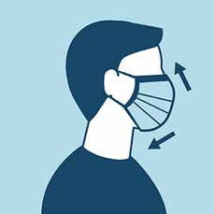
A significant portion of individuals with Covid-19 lack symptoms and even those who eventually develop symptoms can transmit the virus to others before showing symptoms. To prevent the spread the CDC recommends wearing face masks where social distancing measures are difficult to maintain such as the cook line or handing food to a Guest.

Disposable face masks are single use items and are recommended by the CDC as part of standard precautions to prevent the spread of disease.
  - Disposable Masks must be changed daily.
  - Avoid touching the outer surface of the mask during or following procedures as it should be assumed to be contaminated. Do not pull down to talk or wear around your neck.
  - Masks should be close fitting and cover the mouth and nose.

Instructions for putting on the face mask:
  - Face Mask with Ear loops: Hold the mask by the ear loops. Place a loop around each ear.
  - Face Mask with Ties: Bring the mask to your nose level and place the ties over the crown of your head and secure with a bow.
  - Determine the Top: The side of the mask that has a stiff, bendable edge is meant to mold to the shape of your nose.
  - Determine the Front: The colored side of the mask is usually the front and should face away from you, while the white side touches your face.

Instructions for removing the face mask:
  - Clean your hands with soap and water before touching the mask.
  - Face Mask with Ear loops: Hold both ear loops and gently lift and remove the mask.
  - Face Mask with Ties: Untie the bottom bow first then untie the top bow and pull the mask away from you as the ties are loosened.
  - Discard the face mask in the trash.
  - Wash your hands with soap and water for 20 seconds.

Masks worn at work are to prevent the spread of the virus. Train your Team Members on how to properly wear mask.
} How to put on and remove your mask
} How to properly clean the mask if using a cloth (soap and water by hand or washing machine)
} Limit contact between Team Members and Guests. Where face coverings are not mandated, TGI Fridays recommends requiring waitstaff to wear face coverings (as recommended by the CDC) if they have direct contact with Guests.

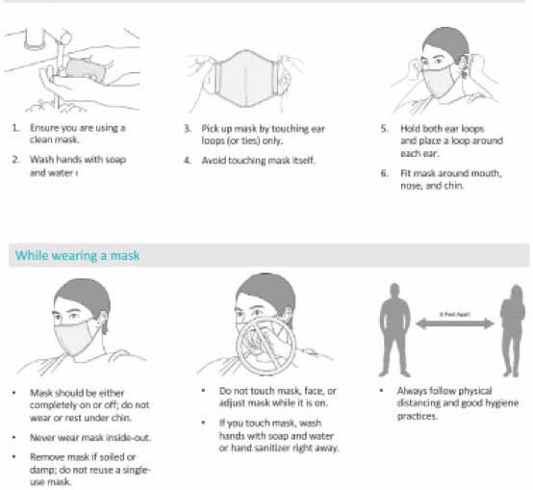
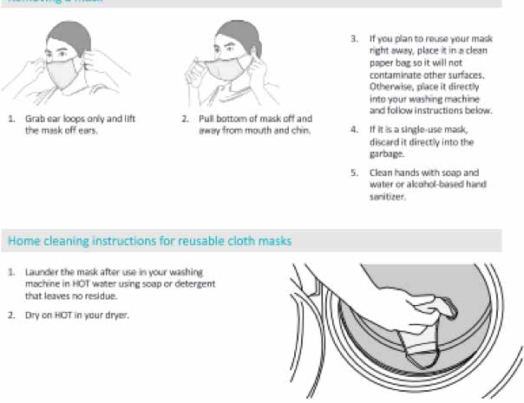

Wearing Gloves
We will wear Gloves for every Guest facing touch point. Gloves should never be used in place of hand washing. If you have a cut or
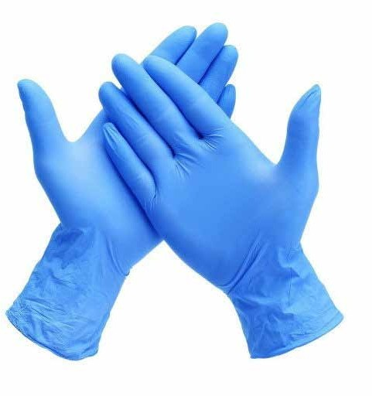
sore, always cover it with a clean bandage. If it is on your hand always wear a glove to protect the bandage and prevent it from falling into food. Gloves minimize bare-hand contact with ready-to-eat food but can contaminate food or spread illness if they are not used properly.
} Train Team Members how to use gloves and how to remove gloves.
} Train Team Members to wash hands before and after each use.
When to wear gloves:
} When delivering food or to go bags to Guests or Delivery Drivers
} When handling payment
} Glove use when touching Ready To Eat foods
} Gloves must be replaced at each Guest interaction

SANITARY, SAFE, AND SPOTLESSLY CLEAN GLOVE PRACTICES:
Wash and dry hands before putting on gloves and after taking off your gloves. If a hand sink isn’t available, you may use hand sanitizer.
} Gloves must be single-use, food grade, latex free, powder free, and without tears or imperfections.
} Use appropriate size of gloves to ensure proper fit.
} Gloves cannot be reused after they have been removed.
} Do not use hand sanitizer on gloves.
Change gloves whenever an activity or workstation change occurs, or whenever the gloves become contaminated, for example:
} After taking a payment.
} After interacting with a Guest.
} After moving from your station and returning after having touched another object, such as a door or the POS.
} After handling raw food and before handling ready-to-eat or cooked food.
} You can wear gloves up to 30 minutes while performing the same task, otherwise discard after each use.
} Note: when handing a Guest a To Go order, you may use one set of Gloves to hand them the bag and process their payment.
Then you must discard them, wash or sanitize your hands before putting on another set of gloves.

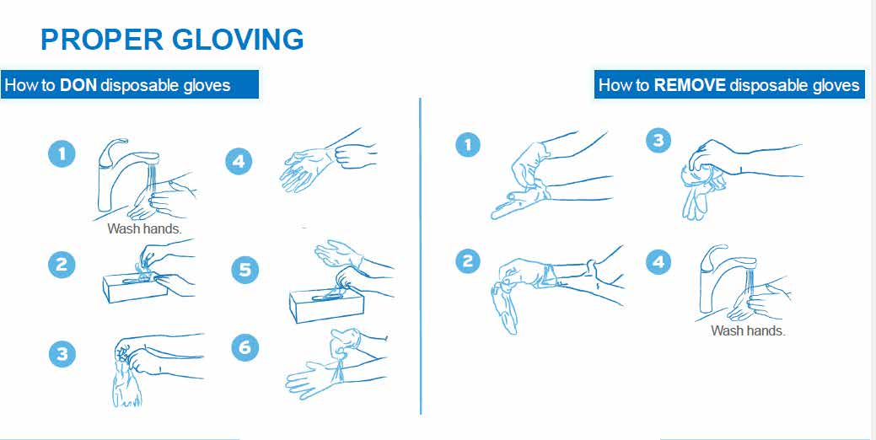

Personal Hygiene
For the Guests’ protection, Steel Pole adherence an all safety procedures must be enforced. Personal hygiene seems simple but it
is one of the biggest causes of illness. There are many things that can contaminate food or spread illness such as scratching your head or other body parts, touching your nose, coughing or sneezing in your hand, and wearing a dirty uniform. As food-handlers, good
personal hygiene is a critical protective measure to prevent contaminating food and causing foodborne illness.
} Uniforms and personal cleanliness are an important part of good personal hygiene. A dirty uniform can harbor dangerous microorganisms that might contaminate food. All clothing and aprons worn must look like-new and be laundered after each shift.
} Always maintain high personal cleanliness standards. Hair can contaminate food. Ensure your hair is clean and pulled away from your face. Wear a clean hat or hair net whenever you are working in the kitchen.
} Jewelry may also contaminate food. The only jewelry allowed in the BOH is a plain wedding band. It is also important to keep your fingernails trimmed and clean.
} Never wear your apron on the back-dock, in the dumpster area, or into the restroom. Aprons should be changed once they become soiled. A fry station Team Member may need to change out his or her apron more often if it becomes soiled with breading. Remember never wipe your hands or hang towels on your apron.

EATING AND DRINKING
Never eat, drink or smoke in the kitchen or any food prep areas. In some locations you may be able to drink from a closed container under certain conditions. Always wash and sanitize your hand after eating or drinking. Check with your manager or trainer to find out what is allowed at your Restaurant.

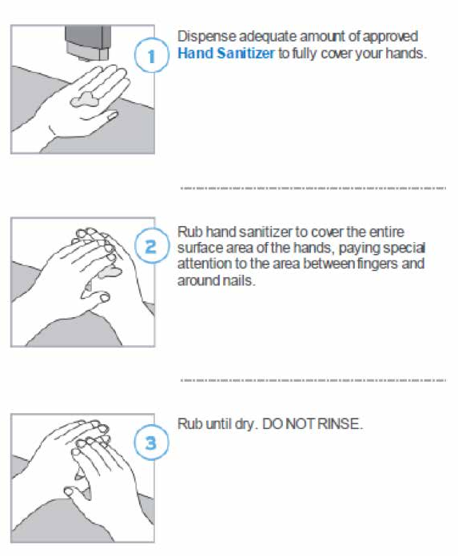
Hand Sanitizing
While washing your hands with soap and water is the preferred
method for cleaning your hands, if soap and water is not readily available, you may use an alcohol-based hand sanitizer.
- The sanitizer must contain 60% alcohol to be effective.
- Sanitizer is not meant to clean dirt or particles off your hands. It is only meant to sanitize otherwise clean-looking hands.

Handwashing
POLICY: All Team Members will follow proper handwashing practices to ensure the safety of food served to Guests.

PROCEDURE: All Team Members in the restaurant must wash hands using the following steps:
- Wash hands (including under the fingernails) and forearms vigorously and thoroughly with soap and warm water (water temperature at the hand sink needs to be minimum 100ºF, Target 110ºF is recommended) for a total time period of 20 seconds.
- Wash hands using soap from a soap dispenser. Lather at least 10 seconds.
- Use a sanitary nailbrush to remove dirt from under fingernails.
- Lather soap between fingers and on hands thoroughly for 10-15 seconds
- Use only hand sinks designated for that purpose. Do not wash hands in sinks in the production area.
- Dry hands with single use towels. Turn off faucets using a paper towel in order to prevent recontamination of clean hands

The restaurant manager will:
- Monitor all Team Members to ensure that they are following proper procedures.
- Ensure adequate supplies are available for proper handwashing.
- Follow up as necessary.

When to wash hands:

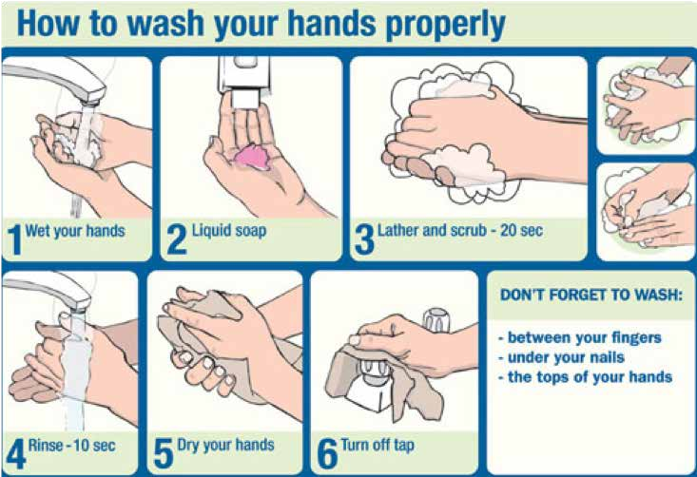
} Upon arrival at work
} After using restroom
} When changing tasks
} After handling cash
} After leaving food prep areas
} After cleaning tasks
} Before returning to food prep or service
} After handling dirty dishes or equipment
} Before or after breaks
} After handling the phone
} After eating, drinking or smoking
} Before donning new gloves
} After handling raw foods
} In between Guest interactions

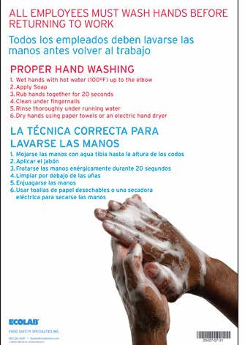
Promote proper handwashing by training and communicating before and during each shift. Place the poster in a prominent place to guide Team Members on how to properly wash their hands.

Post Signs to wash hands at each hand sink. Poster: Hand Washing - $10.71 Ecolab Item Number: 20427-07-31

PRE-OPENING CLEANING GUIDELINES

} Pest Control should have been in place during closure.
} Corporate Restaurants should check Ecolab Reports. Identify if rodent or roach activity occurred and schedule follow up.
} Franchisees be sure pest control is in place. If not, schedule.
} Disinfect entire restaurant with Ecolab Peroxide Spray Disinfection. (see details below and on the next page)
} Completely apply disinfectant until entire targeted surface was wet.
} Surface must remain wet for the contact time (45 seconds) as stated on the product label.

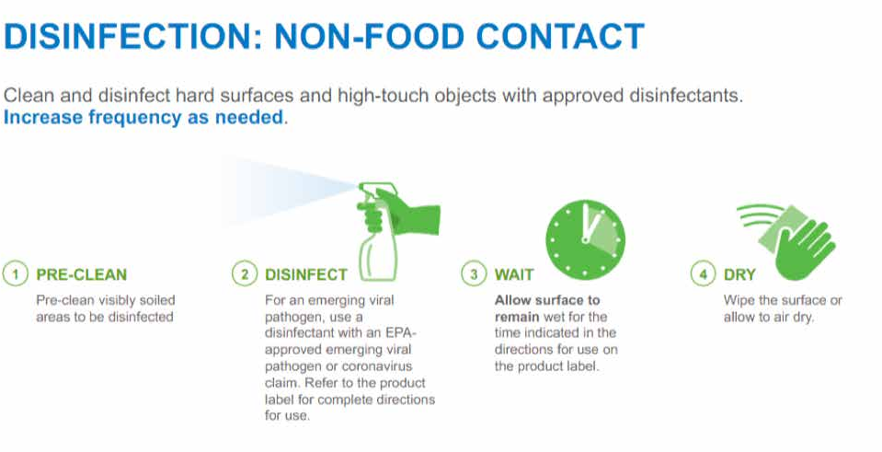

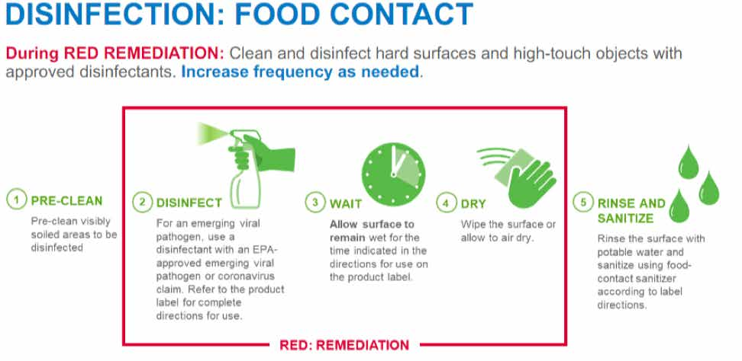

AREAS TO DISINFECT

Kitchen
} Peroxide Disinfectant Cleaner used to treat all surfaces in the Kitchen; Refrigeration Equipment, Oven Handles, Outside surface of Ice Machine, Floors, Walls, Hard Surfaces, Shelves, Tables, Counters, Plumbing fixtures, Sinks, Doors, and Door Handles. No product applied to cooking surfaces such as fryers, stove tops, combi ovens.
} Completely apply disinfectant until entire targeted surface is wet.
} Surface must remain wet for the contact time (45 seconds) as stated on the product label.
} After contact time is met, rinse the surface with fresh water.
} Mop, squeegee, or wiped any excess liquid.
} Wipe dry with disposable towels.
} Dispose of all disposable Personal Protective Equipment and wipes/towels into trash bag.

Dining
} Peroxide Disinfectant Cleaner used to treat all surfaces in the Dining Area: Floors, Walls, Hard Surfaces, Tables, Chairs, Benches, Doors, and Window Seals.
} Completely apply disinfectant until entire targeted surface is wet.
} Surface must remain wet for the contact time (45 seconds) as stated on the product label.
} After contact time is met, rinse the surface with fresh water.
} Mop, squeegee, or wipe any excess liquid.
} Wipe dry with disposable towels.
} Dispose of all disposable Personal Protective Equipment and wipes/towels into trash bag.

Restrooms
} Peroxide Disinfectant Cleaner used to treat all surfaces in the Restrooms, Floors, Walls, Doors and Plumbing Fixtures, Toilets and Sinks.
} Completely apply disinfectant until entire targeted surface is wet.
} Surface must remain wet for the contact time (45 seconds) as stated on the product label.
} After contact time is met, Ecolab rinses the surface with fresh water.
} Mop, squeegee, or wipe any excess liquid.
} Wipe dry with disposable towels.
} Dispose of all disposable Personal Protective Equipment and wipes/towels into trash bag.

CLEANING SCHEDULES

Upon reopening, thoroughly detail-clean and sanitize entire facility, especially if it has been closed. Focus on high-contact areas that would be touched by Team Members or Guests. Do not overlook seldom touched surfaces. Follow sanitizing material guidance to confirm sanitizing strength and to protect surfaces.

- Avoid all food contact surfaces when using disinfectants.
- Between seatings, clean and sanitize digital ordering devices, check presenters, pens, self-service areas, tabletops, chairs, and common touch areas.
- Single-use items should be discarded.
- Remove lemons and unwrapped straws from self-service drink stations.
- Discard menus after each customer use.
- Check restrooms regularly and clean and sanitize them based on frequency of use.
- Make hand sanitizer readily available to Guests.
- Wear disposable gloves for all tasks in the cleaning process, including handling trash.
- Additional personal protective equipment (PPE) might be required based on the cleaning/disinfectant products being used and whether there is a risk of splash.
- Gloves should be removed carefully to avoid contamination of the wearer and the surrounding area.
- Wash your hands often with soap and water for 20 seconds.
- Always wash immediately after removing gloves and after contact with a person who is sick.

Cleaning High Touch Points Every Hour
High Touchpoints must be cleaned every hour. During peak periods, we recommend assigning one person to do this exclusively.
Ensure this person is identifiable to Guests with either a hat, sash or other marking to signify the work they are doing.

All available cleaning and sanitation procedures are available on The Hub. The following pages are the company standard checklists for maintaining a Sanitary, Safe and Spotlessly Clean Restaurant.

Item | Area
Point of sale register/touchscreens | Curb-Side
Pens or other writing utensils | Curb-Side
Clipboards | Curb-Side
Electronic signature pads | Curb-Side
Screen | To Go Area
Counters | To Go Area
Door handles | Server Area
Surfaces inside delivery vehicles | Server Area
Handles of the dispensers (beverage, etc.) | Server Station
Ice scoops | Server Station
Hand-wash sink handles | Server Station
Soap dispenser push plates at hand-wash sink | Server Station
Towel dispenser handle at hand-wash sink | Server Station
Ice scoops | Bar
Hand-wash sink handles | Bar
Soap dispenser push plates at hand-wash sink | Bar
Towel dispenser handle at hand-wash sink | Bar
Lexan Containers and Lids | Bar
Door handles, push plates, thresholds and hand railings | FOH
Dining tables and chairs, if still in service | FOH
Trash receptacle touch points | FOH
Highchairs, if still in service | FOH
Front counter | FOH
Drink Station | FOH
Table condiment | FOH
Menus | FOH
Trays | FOH
Light Switches | FOH
Door handles | Restroom
Sink faucets and toilet handles | Restroom
Towel dispenser handle | Restroom
Soap dispenser push plates | Restroom
Baby changing station | Restroom
Trash receptacle touch points | Restroom
Handles of all equipment doors and operating push buttons | Cookline
Microwave | Cookline
Reach-ins | Cookline
Line Drawers | Cookline

Hand-wash sink handles | Cookline
Soap dispenser push plates at hand-wash sink | Cookline
Towel dispenser handle at hand-wash sink | Cookline
All service area counter surfaces | Cookline
All kitchen/fresh department counter surfaces | Cookline
All stainless steel surfaces | Cookline
Light Switches | Cookline
Light Switches | Dishroom
Dish Machine curtains | Dishroom
3-compartment sink and mop sink | Dishroom
Hand-wash sink handles | Dishroom
Soap dispenser push plates at hand-wash sink | Dishroom
Towel dispenser handle at hand-wash sink | Dishroom
Sneeze guards | Expo
Trash receptacle touch points | Janitorial
Cleaning tools | Janitorial
Self-service Utensils Buckets | Janitorial
Cleaner dispenser push buttons | Janitorial
Light Switches | Office
Telephone keypad and handset | Office
Computers | Office
Office cabinet handles and safe handle | Office
Microphone and point of sale register | Office
FOH tables and chairs | Office
Display screens on equipment | Office
Handles of all equipment doors and operating push buttons | Prep Area
Oven | Prep Area
Ice scoops | Prep Area
Door to ice makers | Prep Area
Hand-wash sink handles | Prep Area
Soap dispenser push plates at hand-wash sink | Prep Area
Towel dispenser handle at hand-wash sink | Prep Area
Lexan Containers and Lids | Prep Area
All service area counter surfaces | Prep Area
All kitchen/fresh department counter surfaces | Prep Area
All stainless steel surfaces | Prep Area
Light Switches | BOH
Door handles and push plates | Walk-ins
Walk-in and other refrigerator handles | Walk-ins
Walk-in refrigerator and freezer plastic | Walk-ins
Freezer handles | Walk-ins

EVERY HOUR HIGH TOUCH POINT CLEANING CHECKLIST

CLEANING SCHEDULES

These items should be cleaned daily. You will find instructions on how to clean each item in the BOH Cleaning Guide. There is also a FOH cleaning schedule. The schedule breaks down what to clean daily, weekly, bi-weekly and monthly. It also describes which chemicals to use.

 | Sauté Stove |  | Non-refrigerated Wells |  | Bun Toaster
 | Eye Burner |  | Reach-ins |  | Station Books
 | Flat Top |  | Kitchen Floors |  | Cutting Boards
 | Computer Equipment |  | Trash Cans |  | Refrigerated Drawers
 | Salad King |  | Back Dock |  | Broiler
     | Microwave  Bread - Chip Drawers Hood/Filter |    | Cheese Melters (Electric and Gas)  Cubbies, Shelving, Windows, |    | Dean Filter Machine  Beverage Fountains (Nozzles and Machines)

 Hot Wells
Sinks and Tables

FOH Cleaning Schedule
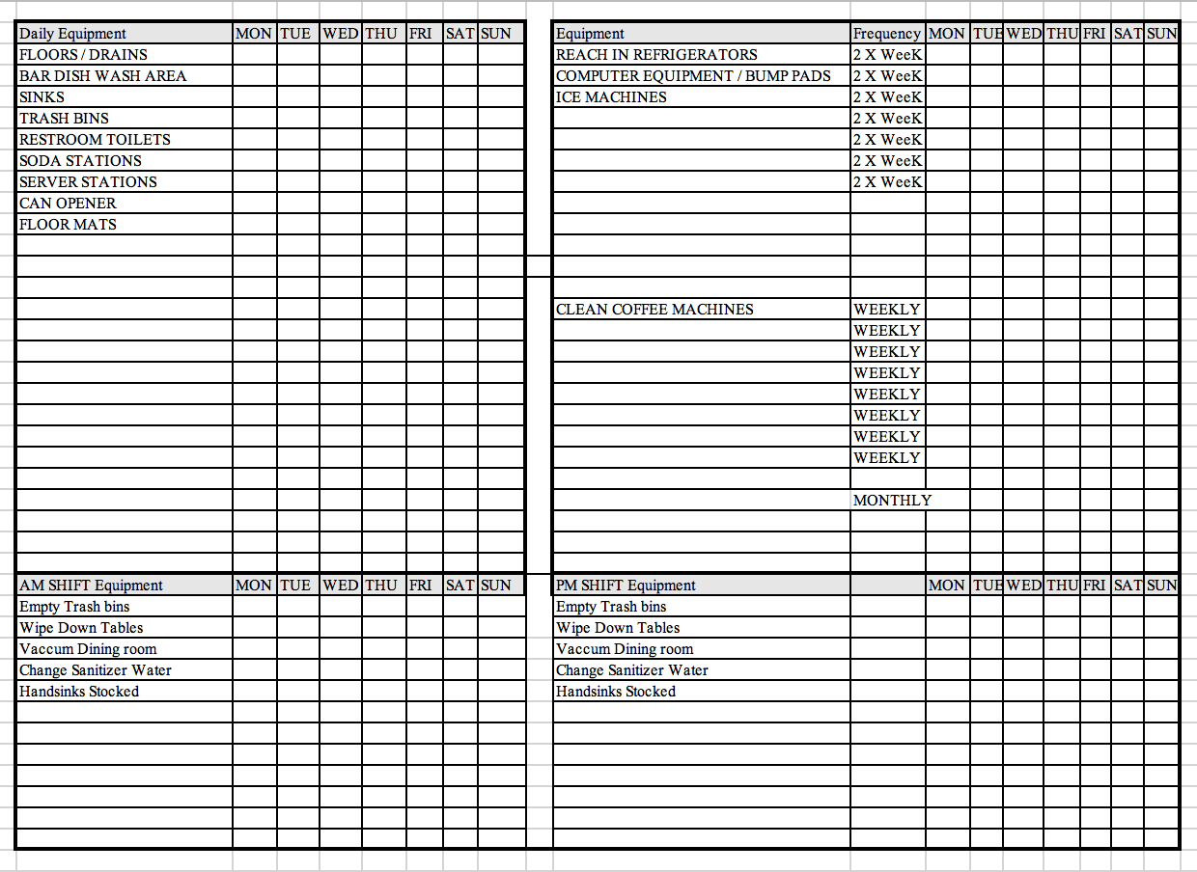
Private and Confidential Information - TGI FridaysTM 2020 25

BOH Cleaning Schedule
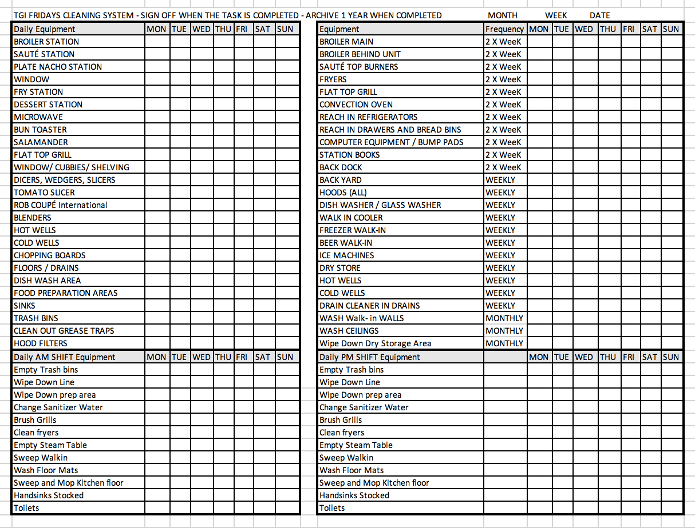

MONTHLY CLEANING CALENDAR

MONTH YEAR
TUESDAY | WEDNESDAY | THURSDAY | FRIDAY | SATURDAY | SUNDAY | MONDAY
Ice Machine1 | Saute Station2 | Fry Station2 | Back Dock3 | Plate Nacho Station2 | Broiler Station2 | Dry Storage Room4: Clean Oven
BOH Misc5./Dish Machine Station | Sauté Station | Fry Station | Back Dock | Plate Nacho Station | Broiler Station | Prep Line6: Clean Oven
Ice Machine | Sauté Station | Fry Station | Back Dock | Plate Nacho Station | Broiler Station | Dry Storage Room/ Clean Oven
BOH Misc./Dish Machine Station | Sauté Station | Fry Station | Back Dock | Plate Nacho Station | Broiler Station | Prep Line/Clean Oven
DETAILS
1Ice Machine - Empty ice machine by filling up all bins, Take apart machine and scrub everything. Rinse, sanitize and refill
2Broiler, Sauté, PN Station & Fry Stations - Scrub all cooking equipment, move out, clean sides and behind (Fry Station also requires boil out)
3Back Dock - Sweep, Power Wash, Deck Brush Mop, Rinse
4Store Rooms - Scrub Walls, Racks & Floors
5BOH Misc. - Wipe Down Walls, Scrub Base Boards
6Prep Line Station - Scrub all Stainless Steel including legs, move tables out, scrub walls and base boards

WEEK 1

WEEK 2

WEEK 3

WEEK 4

WEEK 5
Ask a Manager and Clean Where Needed

Private and Confidential Information - TGI FridaysTM 2020 27

SERV SAFE CERTIFICATION

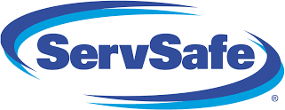
To align with our goal to maintain Sanitary, Safe and Spotlessly Clean, we require all Managers to obtain a Food Protection Manager Certification through the National Restaurant Association’s ServSafe program.

Upon hire or promotion, all new managers will be signed up for a course in Food Safety.

Managers have 90 days to complete the course and pass the exam. In accordance with the SERV Safe guidelines, any manager who does not pass the exam on the first try will have another opportunity to pass the exam within 30 days. Should an individual not pass on the second try, they must wait 90 days to take the exam again.

Once a manager has successfully passed the exam, the National Restaurant Association will send a certificate of SERV Safe Certification to the proctor who will present the certificate to the manager. It is the manager’s responsibility to keep a copy of this certificate to the in your Team Member file as well as notify your direct supervisor of your certification’s pending expiration as needed. The certification is valid for five years from the date that the manager passed the test. This certificate must be hung in the office at all times.

THE RIGHT PEOPLE

Success in your restaurant begins with The Right People. The Right People bring your restaurant to life and execute all the other Operational Absolutes. Read on for help on getting staffed back up for re-opening your restaurant.

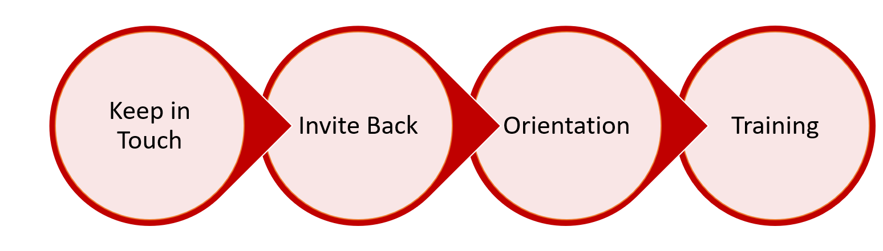
4 STAGES OF RE-STAFFING

Keep in Touch
GOAL: reach out to any furloughed staff that you hope to bring back at least once a week.

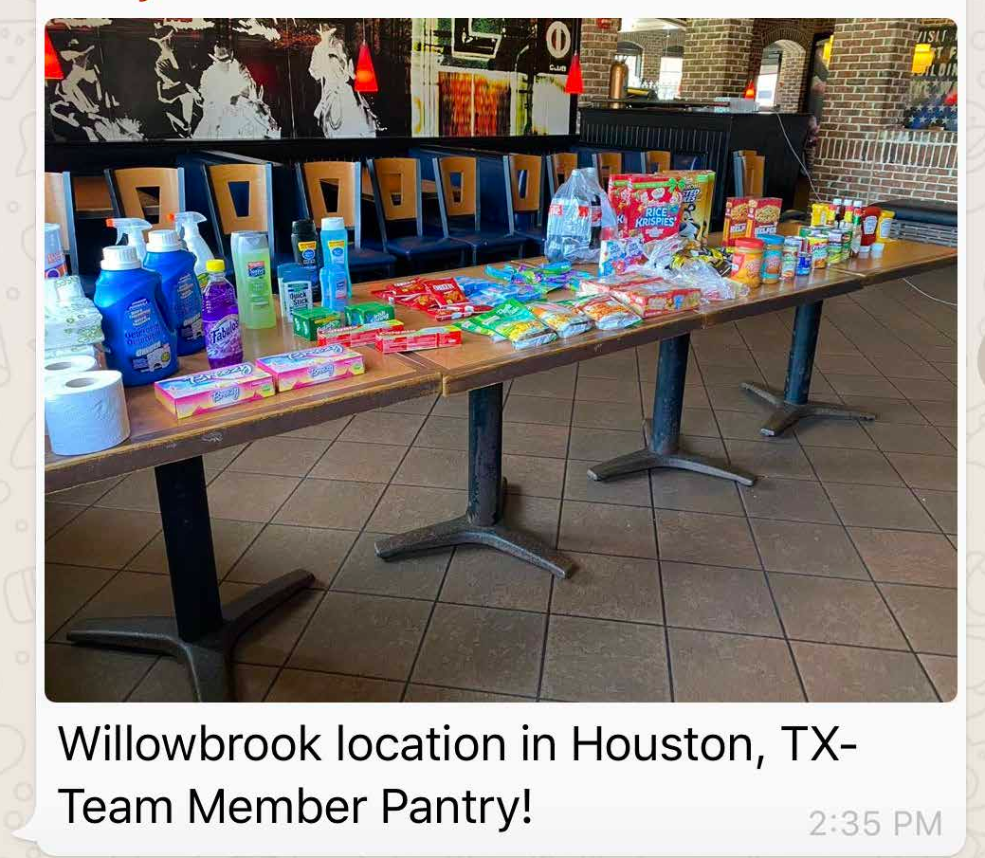
KEY TALKING POINTS:
- Reassure them that you are still thinking of them.
- Tell them specifics on:
  - What you are doing to grow sales
  - What procedures you have in place to keep the current team and your Guests safe
  - Any information you have on when restrictions will be lifted. It’s ok to not know specifics, tell them what you know and any additional information you hope to know soon.
- Remind them of opportunities they can take advantage of:
  - Team Member Pantry
  - Team Member support website
  - Team Member 50% discount at Fridays

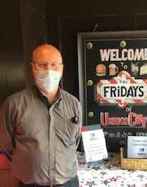

9
Private and Confidential Information - TGI FridaysTM 2020 2
GM’s Keeping in Touch

Mike Morgan from Union City writes, “Hi everyone. Hope you are well. We have 2 cases of 7oz white milks set to expire on 4/25. We are giving these away to anyone that wants to come and get them. Let everyone know they are available. We are here every day from 12 to 9. Come by and take a few. Thanks, Mike.”

Lyneah Crum from Orleans write, “Hey everyone, I hope you are all doing good and keeping your heads up. Miss all your faces, soon we will all be back and rockin like the rockstars you all are. If you need anything, please reach out. Hope are all are in good health.”

INVITING BACK THE RIGHT PEOPLE
GOAL: If you did a good job of keeping in touch with your furloughed staff, you should see 90% of Team Members come back when asked. Try to give your Team Members 2-3 days’ notice before expecting them back to work.

RETURN TO WORK (RTW) TALKING POINTS AND HR BEST PRACTICES

Things to be careful of…
- Furloughed staff are “expected” to return to work, they are not required. Furloughed employees have the right to seek new employment or not return when called.
- Avoid words or phrases like you must, or else, fire, or fired, etc.
- When choosing who to recall, if not everyone, your decision must be based on either performance, availability or merit, and not personal characteristics (age, race, color, disability, pregnancy, gender, national origin, religion, your knowledge of the person's chronic illness).
- Always immediately put a stop to any discriminatory speech or acts observed or reported*

Sample script to use when talking to Team Members:
Hi , how are you and your family? I am happy to tell you that our company once again has work available and would like to bring you back from furlough. I would like to offer you your previous position of at a rate of
$ per hour <Note: you must disclose the position and rate of pay>. Your seniority was not affected by the furlough. If you had accrued PTO/Sick time it will be available upon your return. However, vacation requests will not be approved at this time.

If a Team Member doesn’t want to return because they fear contracting the virus but is not a person at high risk, say this: We are operating a safe workplace and in accordance with CDC, state and local safety and health guidelines. There
currently is no recognized health or safety hazard in our workplace. Explain actions, we are taking to ensure Team Member’s safety at work.

If the Team Member discloses that they are a person at high risk (over 65, underlying illness): Refer them to your HR Manager. HR may need to start the ADA interactive process. DO NOT ask the Team Member what their illness is. It is okay if they tell you.
Recruiting Support
In the event you need to start recruiting to fill your roster,
remember to still think about GOOD HIRES VS. FAST HIRES. Even when time is of the essence, quality can’t be ignored. We need to hire the RIGHT PEOPLE! Go to The Hub>Fridays Culture>Our People>Recruiting and Retention for available tools and resources.

If you need further assistance, contact your Regional Team who may be able to help you post positions for your restaurant and guide you through the process.

If a Team Member chooses not to RTW because they make more from not working and collecting unemployment, say this: I get it, but keep in mind that the additional $600 issued by the federal government is only until the end of July. In addition, we are required to inform the state unemployment agency of your refusal of work. While the decision is solely up to them, they may deny you benefits if they find that suitable work was offered to you and you declined it. Remember also, that you may still be eligible for regular benefits if you are working reduced hours.

If after you explain this to the Team Member they still refuse to return, say this: I’m sorry to see you go. If in future you choose to return to TGI Fridays, you may apply at our website, tgifridays.com. But keep in mind that a future job is not guaranteed. Follow the procedures on the next page titled, “When a Team Member Declines to Return”.

FREQUENTLY ASKED QUESTIONS

I have benefits with the company, what’s going to happen if I refuse to come back? If you refuse to come back it will be perceived as a resignation. COBRA will be offered to you but remember it will cost significantly more than you are paying now.

If I return to work, can I still collect unemployment? It depends on if the hours you regularly work have been reduced. For example: If on average you work 40 hours per week and now work 25 hours per week. You may be eligible for partial unemployment. The decision is up to the state.

Do I have to report to unemployment that I’ve returned to work? Yes, you must report all earnings to your unemployment agency. They will calculate the amount to deduct from your weekly benefit amount and you will be paid the difference, if any.

I am happy to return to work, but I need some time to secure a caretaker for my elderly parent/child who is out of school/person in household diagnosed with Covid19. Try your best to work with the TM. Ask how much time they need and try your best to allow them the time. If you are not able to accommodate a delayed return, let the TM know, "Because of our immediate business needs we are unable to accommodate a delayed return, but you are welcomed to reapply when your situation gets better.
Check with the state unemployment office to see if your situation qualifies you for continued benefits."

I called a TM several times to notify them of our intention to return them to work but they don’t answer. Create a log or note to self with the TM Name, number, date and time you called and the result (voicemail left, message left with someone else, no voicemail set up, rang without answer, etc.). It may come in handy if the person later claims they were discharged.

My best server is five months pregnant; can I call her back to work? Yes, don’t assume that she cannot work because she is pregnant. In some states it may even be viewed as discrimination. Call her and give her the opportunity to decide if she wants to or can return to work. If she cannot due to her pregnancy, notify HR. There may be other types of leave she is eligible for.

IF A TEAM MEMBER DECLINES TO RETURN

- Have the Team Member complete a voluntary resignation form or provide a written statement stating they are declining work and the reason.
- If you are unable to obtain any of the above, document your conversation with the team member on a Resignation - Witness statement form. Include the reason given for declining work.

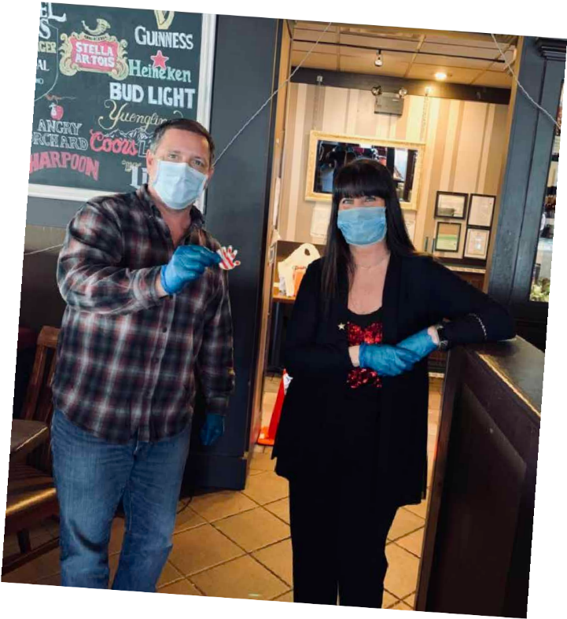
ORIENTATION
GOAL: Team Member feels safe, welcomed back into the family, and understands their role in keeping Team Members and Guests safe.

NIGHT BEFORE – contact Team Members (5 min)
- Reiterate safety procedures to put the Team Member at ease. (e.g., we are stocked on sanitation wipes, sanitizer, gloves, antibacterial soap)
- We have disposable masks, washable masks and you can wear your own if you’re more comfortable that way (note: masks that could be considered scary, controversial or otherwise inappropriate will not be permitted)
- How are you stocked on uniforms? You will be asked to wash your uniforms after every shift (including aprons).
- Remind them of start time

DAY 1 ORIENTATION – GM – 30 minutes
- Have some food and beverage available for Team Members (with appropriate safety measures – tongs, disposable cups, gloves etc.)
- Welcome the Team Members and express how much you've missed the team at the restaurant.
- Catch them up on how the restaurant has supported the community and the Team Members while they were out.
- Present Team Members with a copy of all current and updated policies listed in the Sanitary, Safe, and Spotlessly Clean section of the playbook.
- In UltiPro, Team Member must acknowledge a document to state that they are back from furlough.

Don’t Forget Recognition!
You have an opportunity to come out of this time period with a much stronger culture than you did going in. As you bring more of your team back from furlough, take the opportunity to recognize people who:

  - Worked hard at the restaurant to grow sales and contributed to the restaurant’s ability to bring people back.
  - Come back to the restaurant and quickly become experts in the new procedures and energize the team.

32

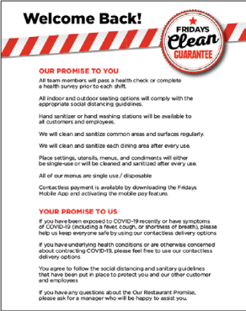
OTHER MANAGER RESPONSIBILITIES

Here are a few things to keep in mind as you plan:

Updating the Floor Plans:
- Depending on local regulations, you may need to either increase the space between your tables or mark tables that can no longer be sat.
- Determine the largest party size allowed in your jurisdiction and make a plan for where you will seat parties that size to maintain required distances from other tables.
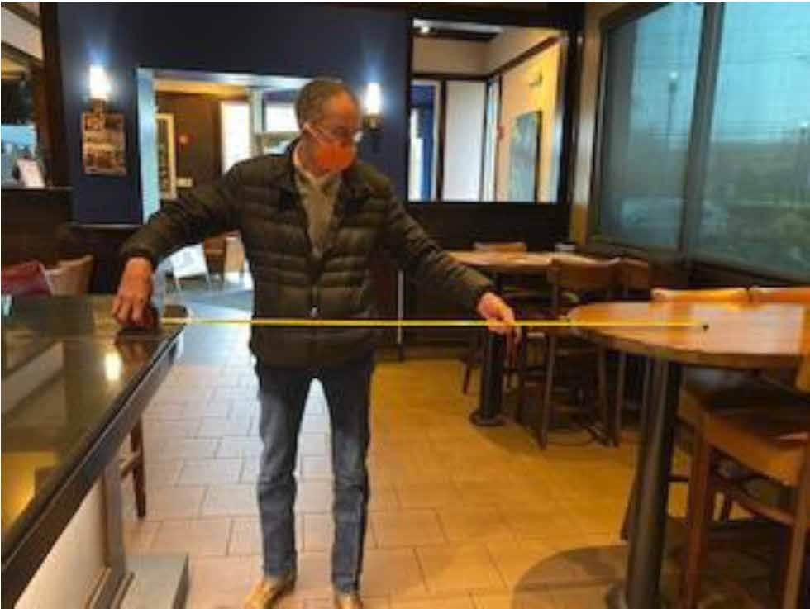
- For each table, identify where a Team Member could stand to be 6 feet away from the Guests AND a place where Food and Drinks could be dropped for Guests to grab (either using Trays/Jacks or an empty table).

The Bar
One difficult decision to make is whether you will open your bar top for Guests. You will likely have regulars looking to sit at the bar again when you open, but here are some things to think about when making your decision:
  - Do your current local or state restrictions prohibit the bar from opening?
  - If you have social distance restrictions, what seating layout will allow the most Guests to be able to sit in your bar area? A bad example would be if you allowed 3 people to sit at a bar top but were unable to seat a whole row of 4 tops next to the bar because the tables are too close.

Manager's Role in the Dining Room
The manager’s job description will not change although their priorities will:
- The managers must prioritize Sanitary, Safe, and Spotlessly Clean and any new rules/regulations around social distancing
- The managers need to ensure that Team Members adhere to the PPE requirements and local regulations.
- In low volume restaurants they can help out, but during peak periods they cannot be cooking or working positions. Managers must be present in the Dining Room and monitoring Guest interactions.

Setting up your Social Distancing Signage
- You will need to post a sign at your front door welcoming Guests back, advising them of your cleaning policies and asking them to stay home if they are exhibiting symptoms.
- Review your restaurant for possible Guest congregation points (e.g., entryway, by the bathrooms, outside) and use appropriate floor decals to help Guests maintain a social distance of 6 ft.
- Once you develop your Social Distance Floor Plan, use the Reserved Table signage to mark tables you will not be able to seat.
- As always, review daily/weekly communications for the most up to date POP instructions.

Welcome Back Door Signage Floor Decals Reserved Table
48 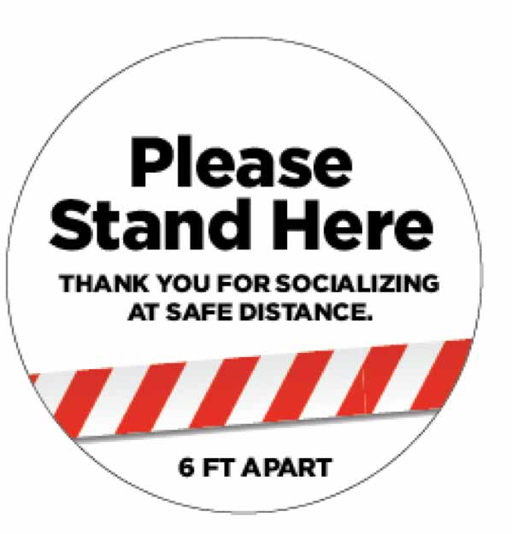 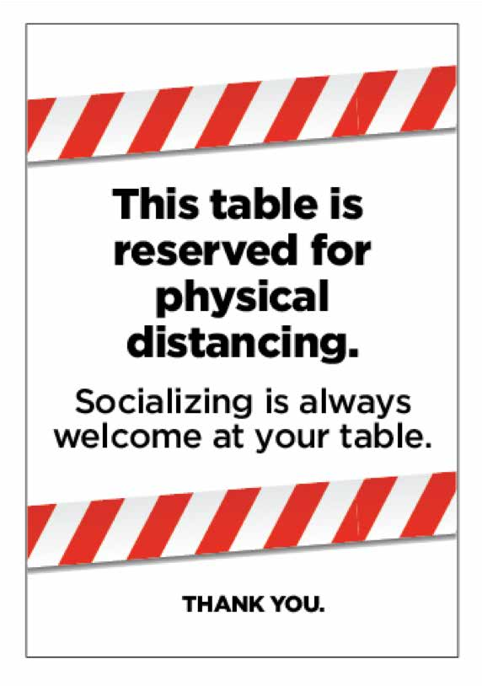

DELIVERING THE PERFECT CURBSIDE FRIDAYS EXPERIENCE

We have earned a lot of trust from our Guests that they can receive a safe, contactless, and Perfect Fridays Experience through Curbside and Delivery. As you open your restaurants back up, you must continue to prioritize and maintain the systems that lead to that Perfect Fridays Curbside Experience.

Contactless Payment Options:
KEY CONTACTLESS OPTIONS

- Guests can pay in advance after placing their order online, through a delivery partner or over the phone.
- Another option for contactless payment is through the mobile app.
  - Guests can call in their orders and pay via our mobile app (where available). You will need to provide the Guest the store number and the check number for their order.
  - You will be able to verify payment when the check closes after the Guest pays.

Contactless Pick Up Options:
- Completely Contactless Service - Come inside and pick up prepaid orders from the Express Pick-Up area. Consider using a side- entrance (if you have one) to keep them away from the entryway flow of Guests.
- Semi Contactless Service
  - Call when they arrive, and we will bring their order out to them
  - Come inside and pay for and pick-up their order
  - Call when they arrive and tell us which curbside pick-up line they are in and we will collect payment and deliver their order

CONTACTLESS CURBSIDE PROCEDURES

Call In Orders
- Guest calls their order into the Restaurant
- Follow all phone scripts to take the order
  - "Thank you for calling your (LOCATION) Fridays, now offering Curbside To Go, this is (YOUR NAME); How I may I help you?"
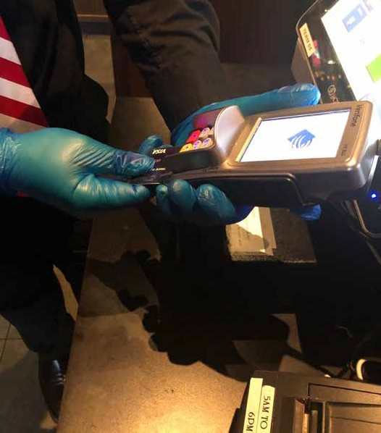
- Instruct the Guest they can pull into the drive through when they arrive and have the option to pay by mobile on our app. You will need to provide the Guest the store number and the check number for their order.

Once the Guest Arrives
- Guest pulls into the dedicated Drive Through Lanes.
- Team Member walks up to car and greets the Guest.
- Ask their name and grab the order from the Express Pick Up staging area.
- Using gloved hands bring the Guest their order to the car.
- If they have not already paid online or with mobile pay, process payment.
  - Use the EMV reader curbside if your WIFI is strong and will reach to the curb.
  - Hand a pen to the Guest to use to complete the transaction. They can use the end to punch their pin code into the machine. Allow the Guest to keep the pen to limit back and forth transmission. If not, make sure you sanitize each pen after use.
  - Let them know they can become a rewards member and use online ordering for an even faster experience next time! OR
  - Using gloved hands take credit card payment and process inside
  - Bring the Guest the processed payment in a sanitized check presenter
    - Hand a pen to the Guest to use to sign their check. Allow the Guest to keep the pen to limit back and forth transmission. If not, make sure you sanitize each pen after use.
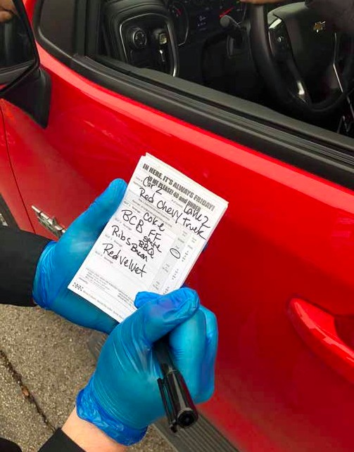
    - Let them know they can become a rewards member and use online ordering for an even faster experience next time!
- Either place in the trunk, passenger side, or backseat floorboard based on the Guest's preference.
- Remove gloves and sanitize hands

50

Curbside Drive Up Orders
- Guest pulls into the dedicated Drive Through Lane
- Team Member walks up to car and Greets the Guest
  - Offer the Guest a paper To Go Menu to review and keep
- Take the Guest's order
  - Remember to write it down and repeat it back!
- Ring in the order and bring the receipt to their car window
- Process payment
  - Use the EMV reader curbside if your WIFI is strong and will reach to the curb
  - Hand a pen to the Guest to use to complete the transaction. They can use the end to punch their pin code into the machine. Allow the Guest to keep the pen to limit back and forth transmission. If not, make sure you sanitize each pen after use.
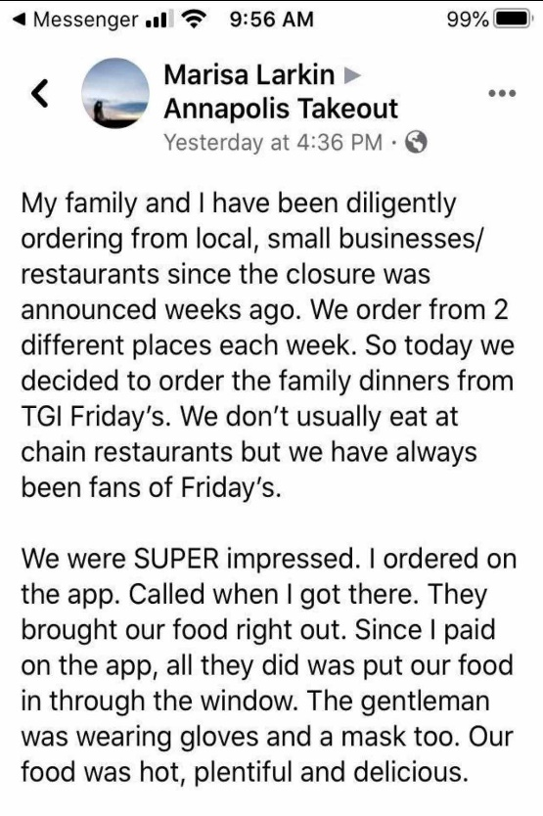
  - Let them know they can become a rewards member and use online ordering for an even faster experience next time!
OR
  - Using gloved hands take credit card payment and process inside
  - Bring the Guest the processed payment in a sanitized check presenter
  - Hand a pen to the Guest to use to sign their check. Allow the Guest to keep the pen to limit back and forth transmission. If not, make sure you sanitize each pen after use.
  - Let them know they can become a rewards member and use online ordering for an even faster experience next time!
- Take the Guest's phone number down in case they leave, and you need to let them know their order is ready.
- Instruct the Guest to pull into a parking spot to the side to wait
- Using gloved hands bring the Guest their order to the car
- Either place in the trunk, passenger side, or backseat floorboard based on the Guest's preference.
- Remove gloves and sanitize hands

Delivery and Online Orders
- Guest places order through 3rd Party Delivery or online at Fridays.com
- Prepare order and place in the Express Pick Up area

Once the Guest Arrives
1. Guest arrives into the restaurant and grabs their order from the Express Pick Up area OR
- Guest pulls into the dedicated Drive Through Lane
- Team Member walks up to car and greets the Guest
- Ask their name and grab the order from the Express Pick Up area
- Using gloved hands bring the Guest their order to the car
- Either place in the trunk, passenger side, or backseat floorboard based on the Guest's preference. Remove gloves and sanitize hands

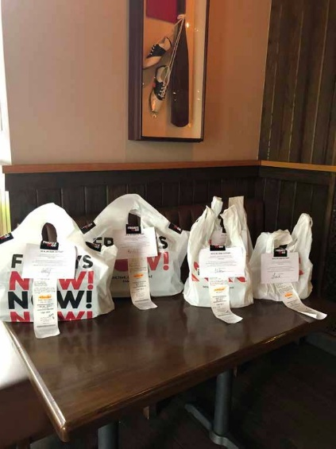
Additional Notes:
- Remember to have as many visual cues to sanitation and cleanliness as possible.
  - Place the hand sanitizer station in the foyer (units coming from Ecosure).
  - Keep a trash can near the door and discard gloves after each interaction.
  - Separate your used sanitized Check Presenters/pens and un-sanitized Check Presenters/pens in 2 distinct lexans.

- Make sure people driving by your Fridays can see we are open and serving the community.
  - HAVE FUN, encourage people to wear costumes and bring attention to the building.
  - Have a person stationed outside to answer questions and direct Guests on the new Curbside model.
  - Make sure your music is playing outside and perimeter lights are on.

- Display all Marketing POP and correctly set up your store fronts.
  - Set up your Marketing road signs, banners and other POP in front of the restaurant.
  - Purchase a box of throw away pens for Guests to keep. This eliminates any cross-contact back and forth to the Guest. If not, make sure you sanitize each pen after use.
    - Print your restaurant phone number to flag these pens as a reminder to the Guest to reorder from your Restaurant.

Guiding Principles for Decisions
As a brand, the Fridays executive team put together guiding principles for making decisions throughout this crisis. As you
bring back your teams and open your dining rooms, consider these principles when making your own decisions and, as always, work with your Directors of Operations to finalize your plans.

    - We care deeply about the health and well-being of our Team Members, Franchisees and Guests. This is our No.1 priority.
    - We will react swiftly to the changing needs of our Team Members, Franchisees and Guests.
    - We recognize our role within our communities and will be a positive contributor whenever possible.
    - We will base our decisions on expert guidance from the Center for Disease Control and World Health Organization. We will follow all legislation and take direction from Government leaders, individual state departments, and local health agencies.
    - We will cease all non-essential spending and unnecessary expenses to responsibly preserve cash.
    - We will commit our resources to mission critical priorities while assisting our restaurant leadership/ownership through the situation.
    - We will communicate promptly and as fully as possible to support the entire Fridays Family.

